Tutoriais sobre CakePHP 3

CakePHP Tutorial Part 2: Add, Edit and Delete Operations

http://www.codexworld.com/cakephp-tutorial-part-2-add-edit-delete-operations/

By: CodexWorldIn: CakePHPLast Updated: Aug 26, 2015
In our previous CakePHP 3.x Tutorial we have learned CakePHP framework installation, configuration, database creation, data listing and basic functionalities. Now we’ll be know about the CakePHP’s advanced functionality through creating a blog post application as an example.
Basic configuration and blog posts listing already have discussed in our previous tutorial. So before starting the advanced tutorial, you can see the CakePHP 3.x Tutorial for Beginners. In this advanced cakephp tutorial we’ll implement the functionality to add, edit, and delete blog posts.
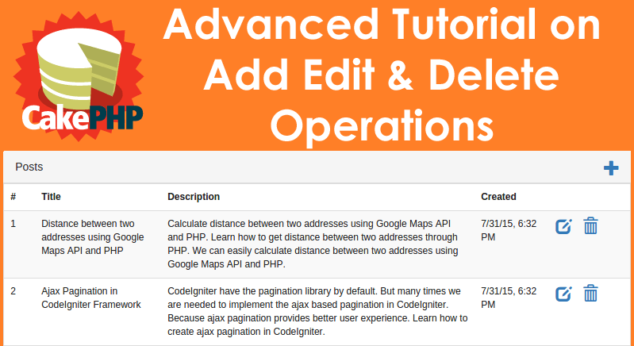

Adding Posts
Controller:
index() function fetch posts from the database and showing the posts. Now let’s allow for the adding of new posts.
For showing success and error message you should need to load the FlashComponent in the PostsController. At first create add() action in the PostsController. add() action render the view of post adding form and try to save the data using the Posts model if the HTTP method of the request was POST. This action also used for show the validation errors or other warnings.
<?php
// src/Controller/PostsController.php
namespace App\Controller;
class PostsController extends AppController
{
public function initialize()
{
parent::initialize();
$this->loadComponent('Flash'); // Include the FlashComponent
}

public function index()
{
$posts = $this->Posts->find('all');
$this->set(compact('posts'));
}

public function add()
{
$post = $this->Posts->newEntity();
if ($this->request->is('post')) {
$post = $this->Posts->patchEntity($post, $this->request->data);
$post->created = date("Y-m-d H:i:s");
$post->modified = date("Y-m-d H:i:s");
if ($this->Posts->save($post)) {
$this->Flash->success(__('Your post has been saved.'));
return $this->redirect(['action' => 'index']);
}
$this->Flash->error(__('Unable to add your post.'));
}
$this->set('post', $post);
}
}
newEntity() is creating a new entity and passing it to the save() method in the Table class.
patchEntity() merge an array of raw data into an existing entity.
Model:
For data validation you need to create src/Model/Table/PostsTable.php model and define the validation rules. validationDefault() method tells CakePHP how to validate your data when the save method is called. We have specified here title and description should not be empty.
<?php
// src/Model/Table/PostsTable.php
namespace App\Model\Table;
use Cake\ORM\Table;
use Cake\Validation\Validator;
class PostsTable extends Table
{
public function initialize(array $config)
{
$this->addBehavior('Timestamp');
}
public function validationDefault(Validator $validator)
{
$validator
->notEmpty('title')
->notEmpty('description');
return $validator;
}
}
View:
Our src/Template/Posts/add.ctp view would be look like below. You’ll need to use CakePHP’s FormHelper to take advantage of the validation features.
<!-- File: src/Template/Posts/add.ctp -->

<h1>Add Blog Post</h1>
<?php
echo $this->Form->create($post);
echo $this->Form->input('title');
echo $this->Form->input('description', ['rows' => '3']);
echo $this->Form->button(__('Save Post'));
echo $this->Form->end();
?>
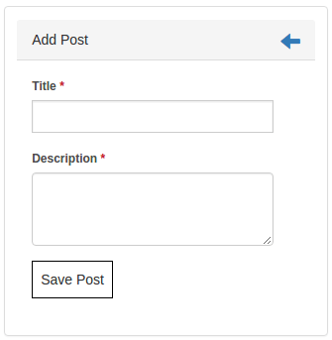
Now update the src/Template/Posts/index.ctp view with “Add New Post” link.
<?= $this->Html->link('Add New Post', ['action' => 'add']) ?>

Editing Posts
Controller:
edit() action first ensures that the user has passed an $id parameter to access an existing record. If they haven’t passed or the post does not exists, throw a NotFoundException.
public function edit($id = null)
{
$post = $this->Posts->get($id);
if ($this->request->is(['post','put'])) {
$post = $this->Posts->patchEntity($post, $this->request->data);
$post->modified = date("Y-m-d H:i:s");
if ($this->Posts->save($post)) {
$this->Flash->success(__('Your post has been updated.'));
return $this->redirect(['action' => 'index']);
}
$this->Flash->error(__('Unable to update your post.'));
}
$this->set('post', $post);
}
View:
src/Template/Posts/edit.ctp view might be look like this.
<!-- File: src/Template/Posts/edit.ctp -->

<h1>Edit Post</h1>
<?php
echo $this->Form->create($post);
echo $this->Form->input('title');
echo $this->Form->input('description', ['rows' => '3']);
echo $this->Form->button(__('Save Post'));
echo $this->Form->end();
?>
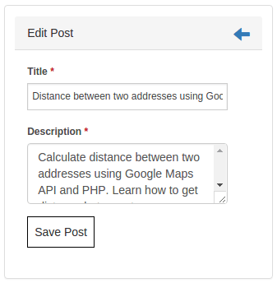
Now update the src/Template/Posts/index.ctp view with “Edit Post” link.
<?= $this->Html->link('Edit', ['action' => 'edit', $post->id]) ?>

Deleting Posts
Controller:
Let’s allow user to delete posts by creating a delete() action in PostsController. delete() action deletes post specified by $id. After deleting the post user would be redirected to the index page.
public function delete($id)
{
$this->request->allowMethod(['post', 'delete']);
$post = $this->Posts->get($id);
if ($this->Posts->delete($post)) {
$this->Flash->success(__('The post with id: {0} has been deleted.', h($id)));
return $this->redirect(['action' => 'index']);
}
}
Now update the src/Template/Posts/index.ctp view with Delte Post link. Also it will better if you show the confirmation message once the Delete link is clicked. $this->Form->postLink() creates a link with JavaScript confirm alert for preventing the accidental click.
<?= $this->Form->postLink(
'Delete',
['action' => 'delete', $post->id],
['confirm' => 'Are you sure?'])
?>

Testing
Go to the homepage page (http://localhost/cakephp/) => you can see posts list with working add, edit and delete links.
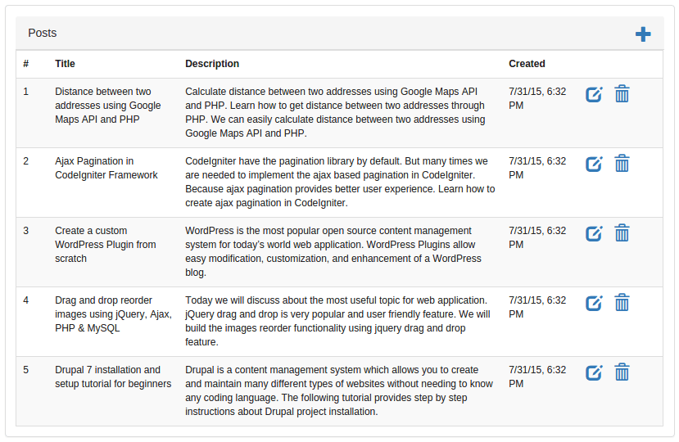

CakePHP Tutorial Part 3: Working with Elements and Layout

By: CodexWorldIn: CakePHPLast Updated: Nov 30, 2016

In our previous tutorial, you have learned add, edit, and delete functionality in CakePHP. Now we’ll show how can you integrate theme in CakePHP using your custom layout. CakePHP’s Element and Layout feature helps you to customize your application layout. This tutorial is designed to help you for CakePHP theme integration by creating elements and layout.
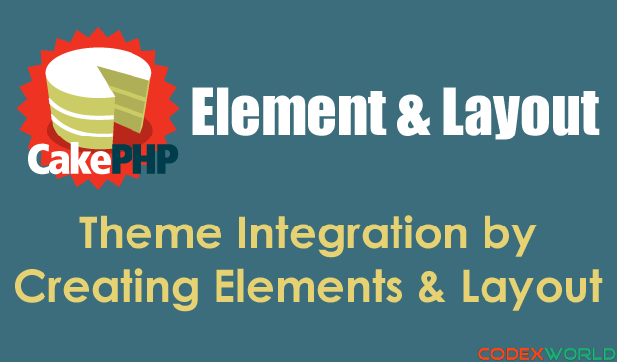
Elements are the small and reusable bits of view code. Layouts are the template files that contain presentational code together with rendered Elements. In this tutorial, we’ll divide the basic bootstrap template into elements and render those elements into our custom layout.
As per our previous tutorial, we already listed the blog posts from the database and also implemented add, edit and delete operations. Now we’ll change the default template with our custom template.
Assume that we have the following basic bootstrap template HTML:
<!DOCTYPE html>
<html lang="en">
<head>
<meta http-equiv="Content-Type" content="text/html; charset=utf-8" />
<title>CakePHP Tutorial by CodexWorld</title>
<!-- Bootstrap Core CSS -->
<link href="https://maxcdn.bootstrapcdn.com/bootstrap/3.3.5/css/bootstrap.min.css" rel="stylesheet">
<!-- Bootstrap Core JavaScript -->
<script src="https://maxcdn.bootstrapcdn.com/bootstrap/3.3.5/js/bootstrap.min.js"></script>
</head>
<body>
<!-- Navigation -->
<nav class="navbar navbar-inverse navbar-fixed-top" role="navigation">
<div class="container">
<div class="navbar-header">
<button type="button" class="navbar-toggle" data-toggle="collapse" data-target="#bs-example-navbar-collapse-1">
<span class="sr-only">Toggle navigation</span>
<span class="icon-bar"></span>
<span class="icon-bar"></span>
<span class="icon-bar"></span>
</button>
<a class="navbar-brand" href="#">CodexWorld</a>
</div>
<div class="collapse navbar-collapse" id="bs-example-navbar-collapse-1">
<ul class="nav navbar-nav">
<li>
<a href="#">Posts</a>
</li>
</ul>
</div>
</div>
</nav>
<!-- Page Content -->
<div id="content" class="container">
<div class="row">
<!-- Main contents will goes here -->
</div>
</div>
<footer>
<div class="row">
<div class="col-lg-12">
<p>Copyright &copy; Your Website 2015</p>
</div>
</div>
</footer>
</body>
</html>

Creating Element:
Based on the HTML we’ll create three elements head, header, and footer. In the src/Template/Element/ directory create three files named head.ctp, header.ctp and footer.ctp.
head.ctp file contains the following code:
<?php
echo $this->Html->charset();
echo $this->Html->css('https://maxcdn.bootstrapcdn.com/bootstrap/3.3.5/css/bootstrap.min.css');
echo $this->Html->script('https://maxcdn.bootstrapcdn.com/bootstrap/3.3.5/js/bootstrap.min.js');
?>
<title>CakePHP Tutorial by CodexWorld</title>
header.ctp file contains the following code:
<!-- Navigation -->
<nav class="navbar navbar-inverse navbar-fixed-top" role="navigation">
<div class="container">
<div class="navbar-header">
<button type="button" class="navbar-toggle" data-toggle="collapse" data-target="#bs-example-navbar-collapse-1">
<span class="sr-only">Toggle navigation</span>
<span class="icon-bar"></span>
<span class="icon-bar"></span>
<span class="icon-bar"></span>
</button>
<a class="navbar-brand" href="#">CodexWorld</a>
</div>
<div class="collapse navbar-collapse" id="bs-example-navbar-collapse-1">
<ul class="nav navbar-nav">
<li>
<?= $this->Html->link('Posts', '/') ?>
</li>
</ul>
</div>
</div>
</nav>
footer.ctp file contains the following code:
<footer>
<div class="row">
<div class="col-lg-12">
<p>Copyright &copy; Your Website 2015</p>
</div>
</div>
</footer>

Creating Layout:
Layouts are stored into the src/Template/Element/Layout/ directory. Create your custom layout src/Template/Element/Layout/frontend.ctp. In this file, elements would be rendered with the main content. frontend.ctp file contains the following code.
<!DOCTYPE html>
<html lang="en">
<head>
<?= $this->element('head') ?>
</head>
<body>
<?= $this->element('header') ?>
<!-- Page Content -->
<div id="content" class="container">
<?= $this->Flash->render() ?>
<div class="row">
<?= $this->fetch('content') ?>
</div>
</div>
<?= $this->element('footer') ?>
</body>
</html>

Use Custom Layout:
You need to tell CakePHP to use your custom layout. In you controller (PostsController) set the layout into the initialize() function. Also you can use the different layout for different function by defining the layout into different functions.
public function initialize(){
parent::initialize();
// Set the layout
$this->viewBuilder()->layout('frontend');
}

Testing:
Open the posts listing page (http://localhost/cakephp/) on the browser, you’ll see the post list with the custom layout.
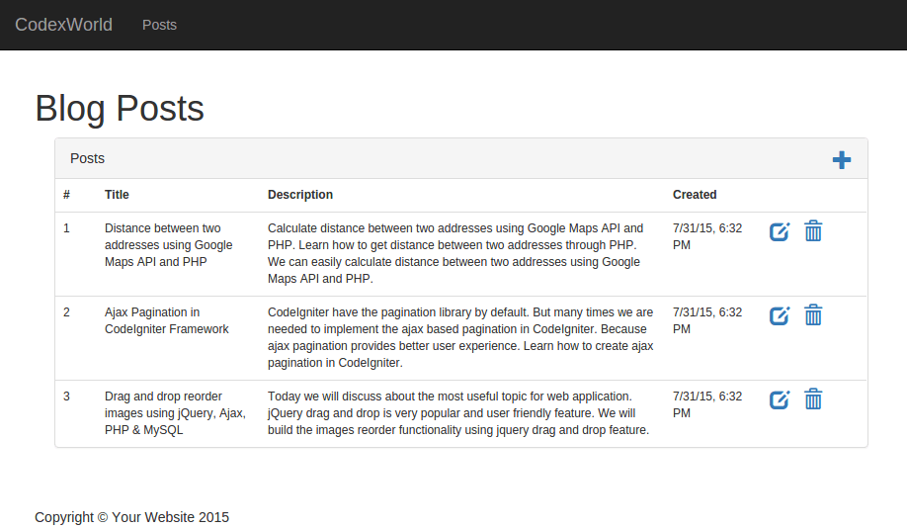

CakePHP comes with one configuration file by default and we can modify it according to our needs. There is one dedicated folder “config” for this purpose. CakePHP comes withdifferent configuration options.

General Configuration
The following table describes the role of various variables and how they affect your CakePHP application.
S.No | Variable Name & Description
1 | debug  Changes CakePHP debugging output.  false = Production mode. No error messages, errors, or warnings shown.  true = Errors and warnings shown.
2 | App.namespace  The namespace to find app classes under.
3 | App.baseUrl  Un-comment this definition if you don’t plan to use Apache’s mod_rewrite with CakePHP. Don’t forget to remove your .htaccess files too.
4 | App.base  The base directory the app resides in. If false, this will be auto detected.
5 | App.encoding  Define what encoding your application uses. This encoding is used to generate the charset in the layout, and encode entities. It should match the encoding values specified for your database.
6 | App.webroot  The webroot directory.
7 | App.wwwRoot  The file path to webroot.
8 | App.fullBaseUrl  The fully qualified domain name (including protocol) to your application’s root.
9 | App.imageBaseUrl  Web path to the public images directory under webroot.
10 | App.cssBaseUrl  Web path to the public css directory under webroot.
11 | App.jsBaseUrl  Web path to the public js directory under webroot.
12 | App.paths  Configure paths for non-class based resources. Supports the plugins, templates, locales subkeys, which allow the definition of paths for plugins, view templates and locale files respectively.
13 | Security.salt  A random string used in hashing. This value is also used as the HMAC salt when doing symmetric encryption.
14 | Asset.timestamp  Appends a timestamp which is last modified time of the particular file at the end of asset files URLs (CSS, JavaScript, Image) when using proper helpers. Valid values −  - (bool) false - Doesn’t do anything (default)  - (bool) true - Appends the timestamp when debug is true  - (string) ‘force’ - Always appends the timestamp

Databases Configuration
Database can be configured in config/app.php file. This file contains a default connection with provided parameters which can be modified as per our choice. The below screenshot shows the default parameters and values which should be modified as per the requirement.

Email can be configured in file config/app.php. It is not required to define email configuration in config/app.php. Email can be used without it; just use the respective methods to set all configurations separately or load an array of configs. Configuration for Email defaults is created using config() and configTransport().

Email Configuration Transport
By defining transports separately from delivery profiles, you can easily re-use transport configuration across multiple profiles. You can specify multiple configurations for production, development and testing. Each transport needs a className. Valid options are as follows −
- Mail − Send using PHP mail function
- Smtp − Send using SMTP
- Debug − Do not send the email, just return the result
You can add custom transports (or override existing transports) by adding the appropriate file to src/Mailer/Transport.Transports should be named YourTransport.php, where 'Your' is the name of the transport. Following is the example of Email configuration transport.

Example
'EmailTransport' => [
'default' => [
'className' => 'Mail',

// The following keys are used in SMTP transports
'host' => 'localhost',
'port' => 25,
'timeout' => 30,
'username' => 'user',
'password' => 'secret',
'client' => null,
'tls' => null,
'url' => env('EMAIL_TRANSPORT_DEFAULT_URL', null),
],
],

Email Delivery Profiles
Delivery profiles allow you to predefine various properties about email messages from your application and give the settings a name. This saves duplication across your application and makes maintenance and development easier. Each profile accepts a number of keys. Following is an example of Email delivery profiles.

Example
'Email' => [
'default' => [
'transport' => 'default',
'from' => 'you@localhost',
],
],
Routing maps your URL to specific controller’s action. In this section, we will see how you can implement routes, how you can pass arguments from URL to controller’s action, how you can generate URLs, and how you can redirect to a specific URL. Normally, routes are implemented in file config/routes.php. Routing can be implemented in two ways −
- static method
- scoped route builder
Here is an example presenting both the types.
// Using the scoped route builder.
Router::scope('/', function ($routes) {
$routes->connect('/', ['controller' => 'Articles', 'action' => 'index']);
});

// Using the static method.
Router::connect('/', ['controller' => 'Articles', 'action' => 'index']);
Both the methods will execute the index method of ArticlesController. Out of the two methods scoped route builder gives better performance.

Connecting Routes
Router::connect() method is used to connect routes. The following is the syntax of the method −
static Cake\Routing\Router::connect($route, $defaults =[], $options =[])
There are three arguments to the Router::connect() method −
- The first argument is for the URL template you wish to match.
- The second argument contains default values for your route elements.
- The third argument contains options for the route which generally contains regular expression rules.
Here is the basic format of a route −
$routes->connect(
'URL template',
['default' => 'defaultValue'],
['option' => 'matchingRegex']
);

Example
Make changes in the config/routes.php file as shown below.
config/routes.php
<?php
use Cake\Core\Plugin;
use Cake\Routing\RouteBuilder;
use Cake\Routing\Router;

Router::defaultRouteClass('DashedRoute');
Router::scope('/', function (RouteBuilder $routes) {
$routes->connect('/', ['controller' => 'Tests', 'action' => 'index']);
$routes->connect('/pages/*', ['controller' => 'Pages', 'action' => 'display']);
$routes->fallbacks('DashedRoute');
});
Plugin::routes();
Create a TestsController.php file at src/Controller/TestsController.php. Copy the following code in the controller file.
src/Controller/TestsController.php
<?php
namespace App\Controller;
use App\Controller\AppController;

class TestsController extends AppController{
public function index(){
}
}
?>
Create a folder Tests under src/Template and under that folder create a View file called index.ctp. Copy the following code in that file.
src/Template/Tests/index.ctp
This is CakePHP tutorial and this is an example of connecting routes.
Execute the above example by visiting the following URL.
http://localhost:85/CakePHP/
The above URL will yield the following output.
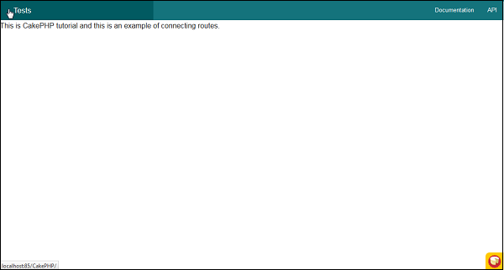

Passed Arguments
Passed arguments are the arguments which are passed in the URL. These arguments can be passed to controller’s action. These passed arguments are given to your controller in three ways.

As arguments to the action method
Following example shows how we can pass arguments to the action of the controller.
Visit the following URL − http://localhost:85/CakePHP/tests/value1/value2
This will match the following route line.
$routes->connect('tests/:arg1/:arg2', ['controller' => 'Tests', 'action' =>
'index'],['pass' => ['arg1', 'arg2']]);
Here the value1 from URL will be assigned to arg1 and value2 will be assigned to arg2.

As numerically indexed array
Once the argument is passed to the controller’s action, you can get the argument with the following statement.
$args = $this->request->params[‘pass’]
The arguments passed to controller’s action will be stored in $args variable.

Using routing array
The argument can also be passed to action by the following statement −
$routes->connect('/', ['controller' => 'Tests', 'action' => 'index',5,6]);
The above statement will pass two arguments 5, and 6 to TestController’s index() method.

Example
Make Changes in the config/routes.php file as shown in the following program.
config/routes.php
<?php
use Cake\Core\Plugin;
use Cake\Routing\RouteBuilder;
use Cake\Routing\Router;

Router::defaultRouteClass('DashedRoute');
Router::scope('/', function (RouteBuilder $routes) {
$routes->connect('tests/:arg1/:arg2', ['controller' => 'Tests', 'action'=>
'index'],['pass' =>['arg1', 'arg2']]);

$routes->connect('/pages/*', ['controller' => 'Pages', 'action' => 'display']);
$routes->fallbacks('DashedRoute');
});

Plugin::routes();
Create a TestsController.php file at src/Controller/TestsController.php. Copy the following code in the controller file.
src/Controller/TestsController.php
<?php
namespace App\Controller;
use App\Controller\AppController;

class TestsController extends AppController{
public function index($arg1,$arg2){
$this->set('argument1',$arg1);
$this->set('argument2',$arg2);
}
}
?>
Create a folder Tests at src/Template and under that folder create a View file called index.ctp. Copy the following code in that file.
src/Template/Tests/index.ctp
This is CakePHP tutorial and this is an example of Passed arguments.<br />
Argument-1: <?=$argument1?><br />
Argument-2: <?=$argument2?><br />
Execute the above example by visiting the following URL.
http://localhost:85/CakePHP/tests/Virat/Kunal
Upon execution, the above URL will produce the following output.
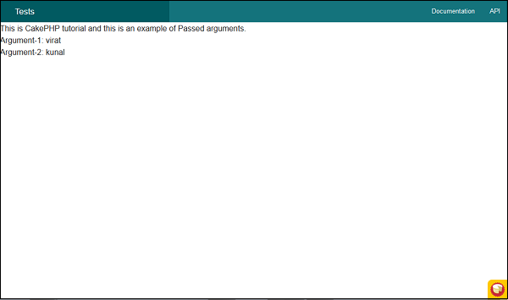

This is a cool feature of CakePHP. Using the generated URLs, we can easily change the structure of URL in the application without modifying the whole code.
url( string|array|null $url null , boolean $full false )
The above function will take two arguments −
- The first argument is an array specifying any of the following − 'controller', 'action', 'plugin'. Additionally, you can provide routed elements or query string parameters. If string, it can be given the name of any valid url string.
- If true, the full base URL will be prepended to the result. Default is false.

Example
Make Changes in the config/routes.php file as shown in the following program.
config/routes.php
<?php
use Cake\Core\Plugin;
use Cake\Routing\RouteBuilder;
use Cake\Routing\Router;

Router::defaultRouteClass('DashedRoute');
Router::scope('/', function (RouteBuilder $routes){
$routes->connect('/generate',['controller'=>'Generates','action'=>'index']);
});

Plugin::routes();
Create a GeneratesController.php file at src/Controller/GeneratesController.php. Copy the following code in the controller file.
src/Controller/GeneratesController.php
<?php
namespace App\Controller;
use App\Controller\AppController;
use Cake\ORM\TableRegistry;
use Cake\Datasource\ConnectionManager;

class GeneratesController extends AppController{
public function index(){
}
}
?>
Create a folder Generates at src/Template and under that folder create a View file called index.ctp. Copy the following code in that file.
src/Template/Generates/index.ctp
This is CakePHP tutorial and this is an example of Generating URLs.
Execute the above example by visiting the following URL −
http://localhost:85/CakePHP/generate
The above URL will produce the following output −
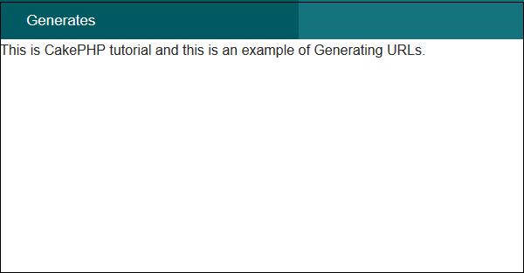

CakePHP - Redirect Routing
Redirect routing is useful when we want to inform client applications that this URL has been moved. The URL can be redirected using the following function.
static Cake\Routing\Router::redirect($route, $url, $options =[])
There are three arguments to the above function −
- A string describing the template of the route.
- A URL to redirect to.
- An array matching the named elements in the route to regular expressions which that element should match.

Example
Make Changes in the config/routes.php file as shown below. Here, we have used controllers that were created previously.
config/routes.php
<?php
use Cake\Core\Plugin;
use Cake\Routing\RouteBuilder;
use Cake\Routing\Router;

Router::defaultRouteClass('DashedRoute');
Router::scope('/', function (RouteBuilder $routes) {
$routes->connect('/generate2', ['controller' => 'Tests', 'action' => 'index']);
$routes->redirect('/generate1','http://tutorialspoint.com/');
$routes->connect('/generate_url',['controller'=>'Generates','action'=>'index']);
$routes->fallbacks('DashedRoute');
});
Plugin::routes();
Execute the above example by visiting the following URLs.
- URL 1 — http://localhost:85/CakePHP/generate_url
- URL 2 — http://localhost:85/CakePHP/generate1
- URL 3 — http://localhost:85/CakePHP/generate2

Output for URL 1
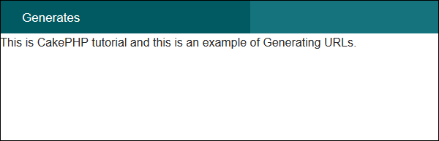

Output for URL 2
You will be redirected to http://tutorialspoint.com

Output for URL 3
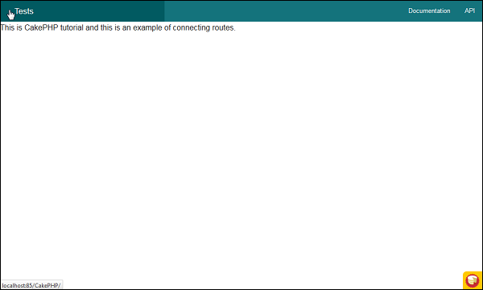

CakePHP - Controllers
The controller as the name indicates controls the application. It acts like a bridge between models and views. Controllers handle request data, makes sure that correct models are called and right response or view is rendered. Methods in the controllers’ class are called actions. Each controller follows naming conventions. The Controller class names are in plural form, Camel Cased, and end in Controller − PostsController.

AppController
The AppConttroller class is the parent class of all applications’ controllers. This class extends the Controller class of CakePHP. AppController is defined at src/Controller/AppController.php. The file contains the following code.
<?php
namespace App\Controller;
use Cake\Controller\Controller;
use Cake\Event\Event;

class AppController extends Controller{
public function initialize(){
parent::initialize();
$this->loadComponent('RequestHandler');
$this->loadComponent('Flash');
}
public function beforeRender(Event $event){
if (!array_key_exists('_serialize', $this->viewVars) &&
in_array($this->response->type(), ['application/json', application/xml'])) {
$this->set('_serialize', true);
}
}
}
AppController can be used to load components that will be used in every controller of your application. The attributes and methods created in AppController will be available in all controllers that extend it. The initialize() method will be invoked at the end of controller’s constructor to load components.

Controller Actions
The methods in the controller class are called Actions. Actions are responsible for sending appropriate response for browser/user making the request. View is rendered by the name of action, i.e., the name of method in controller.

Example
class RecipesController extends AppController{
public function view($id){
// Action logic goes here.
}
public function share($customerId, $recipeId){
// Action logic goes here.
}
public function search($query){
// Action logic goes here.
}
}
As you can see in the above example, the RecipesController has 3 actions − View, Share, and Search.

Redirecting
For redirecting a user to another action of the same controller, we can use the setAction() method. The following is the syntax for the setAction() method −

Syntax
Cake\Controller\Controller::setAction($action, $args...)
The following code will redirect the user to index action of the same controller.
$this->setAction('index');
The following example shows the usage of the above method.

Example
Make changes in the config/routes.php file as shown in the following program.
config/routes.php
<?php
use Cake\Core\Plugin;
use Cake\Routing\RouteBuilder;
use Cake\Routing\Router;

Router::defaultRouteClass('DashedRoute');
Router::scope('/', function (RouteBuilder $routes) {
$routes->connect('/redirectcontroller',['
controller'=>'Redirects','action'=>'action1']);

$routes->connect('/redirectcontroller2',['
controller'=>'Redirects','action'=>'action2']);

$routes->fallbacks('DashedRoute');
});
Plugin::routes();
Create a RedirectsController.php file at src/Controller/RedirectsController.php. Copy the following code in the controller file.
src/Controller/RedirectsController.php
<?php
namespace App\Controller;
use App\Controller\AppController;
use Cake\ORM\TableRegistry;
use Cake\Datasource\ConnectionManager;

class RedirectsController extends AppController{
public function action1(){
}
public function action2(){
echo "redirecting from action2";
$this->setAction('action1');
}
}
?>
Create a directory Redirects at src/Template and under that directory create a Viewfile called action1.ctp. Copy the following code in that file.
src/Template/Redirects/action1.ctp
This is an example of how to redirect within controller.
Execute the above example by visiting the following URL.
http://localhost:85/CakePHP/redirect-controller

Output
Upon execution, you will receive the following output.
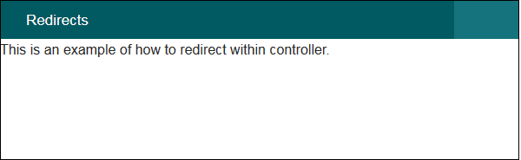
Now, visit the following URL − http://localhost:85/CakePHP/redirect-controller2
The above URL will give you the following output.
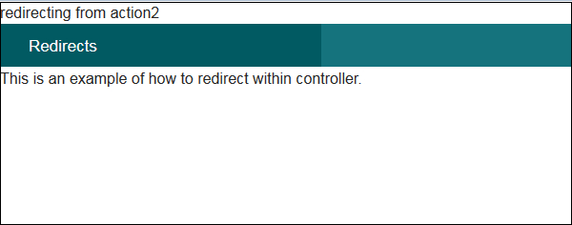

Loading Models
In CakePHP, a model can be loaded using the loadModel() method. The following is the syntax for the loadModel() method.

Syntax
Cake\Controller\Controller::loadModel(string $modelClass, string $type)
There are two arguments to the above function −
- The first argument is the name of model class.
- The second argument is the type of repository to load.

Example
If you want to load Articles model in a controller, then it can be loaded by writing the following line in controller’s action.
$this->loadModel('Articles');

CakePHP - Views
The letter “V” in the MVC is for Views. Views are responsible for sending output to user based on request. View Classes is a powerful way to speed up the development process.

View Templates
The View Templates file of CakePHP has default extension .ctp (CakePHP Template). These templates get data from controller and then render the output so that it can be displayed properly to the user. We can use variables, various control structures in template.
Template files are stored in src/Template/, in a directory named after the controller that uses the files, and named after the action it corresponds to. For example, the View file for the Products controller’s “view()” action, would normally be found in src/Template/Products/view.ctp.
In short, the name of the controller (ProductsController) is same as the name of the folder (Products) but without the word Controller and name of action/method (view()) of the controller (ProductsController) is same as the name of the View file(view.ctp).

View Variables
View variables are variables which get the value from controller. We can use as many variables in view templates as we want. We can use the set() method to pass values to variables in views. These set variables will be available in both the view and the layout your action renders. The following is the syntax of the set() method.

Syntax
Cake\View\View::set(string $var, mixed $value)
This method takes two arguments − the name of the variable and its value.

Example
Make Changes in the config/routes.php file as shown in the following program.
config/routes.php
<?php
use Cake\Core\Plugin;
use Cake\Routing\RouteBuilder;
use Cake\Routing\Router;

Router::defaultRouteClass('DashedRoute');
Router::scope('/', function (RouteBuilder $routes) {
$routes->connect('template',['controller'=>'Products','action'=>'view']);
$routes->fallbacks('DashedRoute');
});
Plugin::routes();
Create a ProductsController.php file at src/Controller/ProductsController.php. Copy the following code in the controller file.
src/Controller/ProductsController.php
<?php
namespace App\Controller;
use App\Controller\AppController;

class ProductsController extends AppController{
public function view(){
$this->set('Product_Name','XYZ');
}
}
?>
Create a directory Products at src/Template and under that folder create a View file called view.ctp. Copy the following code in that file.
src/Template/Products/view.ctp
Value of variable is: <?php echo $Product_Name; ?>
Execute the above example by visiting the following URL.
http://localhost:85/CakePHP/template

Output
The above URL will produce the following output.
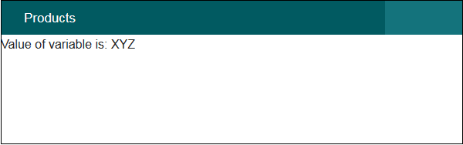

CakePHP - Extending Views
Many times, while making web pages, we want to repeat certain part of pages in other pages. CakePHP has such facility by which one can extend view in another view and for this, we need not repeat the code again. The extend() method is used to extend views in View file. This method takes one argument, i.e., the name of the view file with path. Don’t use extension .ctp while providing the name of the View file.

Example
Make changes in the config/routes.php file as shown in the following program.
config/routes.php
<?php
use Cake\Core\Plugin;
use Cake\Routing\RouteBuilder;
use Cake\Routing\Router;

Router::defaultRouteClass('DashedRoute');
Router::scope('/', function (RouteBuilder $routes) {
$routes->connect('extend',['controller'=>'Extends','action'=>'index']);
$routes->fallbacks('DashedRoute');
});
Plugin::routes();
Create a ExtendsController.php file at src/Controller/ExtendsController.php. Copy the following code in the controller file.
src/Controller/ExtendsController.php
<?php
namespace App\Controller;
use App\Controller\AppController;

class ExtendsController extends AppController{
public function index(){
}
}
?>
Create a directory Extends at src/Template and under that folder create a View file called header.ctp. Copy the following code in that file.
src/Template/Extends/header.ctp
<div align = "center"><h1>Common Header</h1></div>

<?= $this->fetch('content') ?>
Create another View under Extends directory called index.ctp. Copy the following code in that file. Here we are extending the above view header.ctp.
src/Template/Extends/index.ctp
<?php $this->extend('header'); ?>
This is an example of extending view.
Execute the above example by visiting the following URL.
http://localhost:85/CakePHP/extend

Output
Upon execution, you will receive the following output.
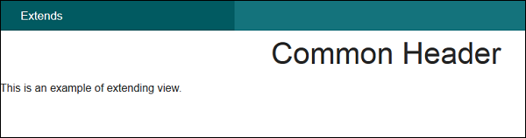

CakePHP - View Elements
Certain parts of the web pages are repeated on multiple web pages but at different locations. CakePHP can help us reuse these repeated parts. These reusable parts are called Elements − help box, extra menu etc. An element is basically a mini-view. We can also pass variables in elements.
Cake\View\View::element(string $elementPath, array $data, array $options =[])
There are three arguments to the above function −
- The first argument is the name of the template file in the /src/Template/Element/ folder.
- The second argument is the array of data to be made available to the rendered view.
- The third argument is for the array of options. e.g. cache.
Out of the 3 arguments, the first one is compulsory while, the rest are optional.

Example
Create an element file at src/Template/Element directory called helloworld.ctp. Copy the following code in that file.
src/Template/Element/helloworld.ctp
<p>Hello World</p>
Create a folder Elems at src/Template and under that directory create a View file called index.ctp. Copy the following code in that file.
src/Template/Elems/index.ctp
Element Example: <?php echo $this→element('helloworld'); ?>
Make Changes in the config/routes.php file as shown in the following program.
config/routes.php
<?php
use Cake\Core\Plugin;
use Cake\Routing\RouteBuilder;
use Cake\Routing\Router;

Router::defaultRouteClass('DashedRoute');
Router::scope('/', function (RouteBuilder $routes) {
$routes->connect('/elementexample',['controller'=>'Elems','action'=>'index']);
$routes->fallbacks('DashedRoute');
});
Plugin::routes();
Create an ElemsController.php file at src/Controller/ElemsController.php. Copy the following code in the controller file.
src/Controller/ElemsController.php
<?php
namespace App\Controller;
use App\Controller\AppController;
use Cake\ORM\TableRegistry;
use Cake\Datasource\ConnectionManager;

class ElemsController extends AppController{
public function index(){
}
}
?>
Execute the above example by visiting the following URL.
http://localhost:85/CakePHP/element-example

Output
Upon execution, the above URL will give you the following output.
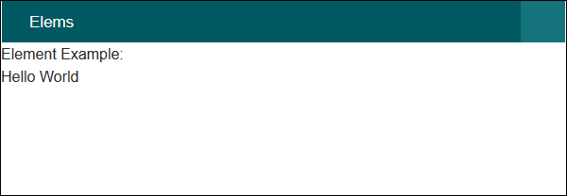

CakePHP - View Events
There are several callbacks/events that we can use with View Events. These events are helpful to perform several tasks before something happens or after something happens. The following is a list of callbacks that can be used with CakePHP.
S.No | Event Function & Description
1 | Helper::beforeRender(Event $event, $viewFile)  The beforeRender method is called after the controller’s beforeRender method but before the controller renders view and layout. This receives the file being rendered as an argument.
2 | Helper::beforeRenderFile(Event $event, $viewFile)  This method is called before each view file is rendered. This includes elements, views, parent views and layouts.
3 | Helper::afterRenderFile(Event $event, $viewFile, $content)  This method is called after each View file is rendered. This includes elements, views,parent views and layouts. A callback can modify and return $content to change how the rendered content will be displayed in the browser.
4 | Helper::afterRender(Event $event, $viewFile)  This method is called after the view has been rendered but before the layout rendering has started.
5 | Helper::beforeLayout(Event $event, $layoutFile)  This method is called before the layout rendering starts. This receives the layout filename as an argument.
6 | Helper::afterLayout(Event $event, $layoutFile)  This method is called after the layout rendering is complete. This receives the layout filename as an argument.

CakePHP - Working with Database
Working with database in CakePHP is very easy. We will understand the CRUD (Create, Read, Update, Delete) operations in this chapter. Before we proceed, we need to create the following users’ table in the database.
CREATE TABLE `users` (
`id` int(11) NOT NULL AUTO_INCREMENT,
`username` varchar(50) NOT NULL,
`password` varchar(255) NOT NULL,
PRIMARY KEY (`id`)
)
ENGINE = InnoDB AUTO_INCREMENT = 7 DEFAULT CHARSET = latin1
Further, we also need to configure our database in config/app.php file.

Insert a Record
To insert a record in database, we first need to get hold of a table using TableRegistry class. We can fetch the instance out of registry using get() method. The get() method will take the name of the database table as an argument.
This new instance is used to create new entity. Set necessary values with the instance of new entity. We now have to call the save() method with TableRegistry class’s instance which will insert new record in database.

Example
Make changes in the config/routes.php file as shown in the following program.
config/routes.php
<?php
use Cake\Core\Plugin;
use Cake\Routing\RouteBuilder;
use Cake\Routing\Router;

Router::defaultRouteClass('DashedRoute');
Router::scope('/', function (RouteBuilder $routes) {
$routes->connect('/users/add', ['controller' => 'Users', 'action' => 'add']);
$routes->fallbacks('DashedRoute');
});
Plugin::routes();
Create a UsersController.php file at src/Controller/UsersController.php. Copy the following code in the controller file.
src/controller/UsersController.php
<?php
namespace App\Controller;
use App\Controller\AppController;
use Cake\ORM\TableRegistry;
use Cake\Datasource\ConnectionManager;
use Cake\Auth\DefaultPasswordHasher;

class UsersController extends AppController{
public function add(){
if($this->request->is('post')){
$username = $this->request->data('username');
$hashPswdObj = new DefaultPasswordHasher;
$password = $hashPswdObj->hash($this->request->data('password'));
$users_table = TableRegistry::get('users');
$users = $users_table->newEntity();
$users->username = $username;
$users->password = $password;

if($users_table->save($users))
echo "User is added.";
}
}
}
?>
Create a directory Users at src/Template and under that directory create a View file called add.ctp. Copy the following code in that file.
src/Template/Users/add.ctp
<?php
echo $this->Form->create("Users",array('url'=>'/users/add'));
echo $this->Form->input('username');
echo $this->Form->input('password');
echo $this->Form->button('Submit');
echo $this->Form->end();
?>
Execute the above example by visiting the following URL.
http://localhost:85/CakePHP/users/add

Output
Upon execution, you will receive the following output.
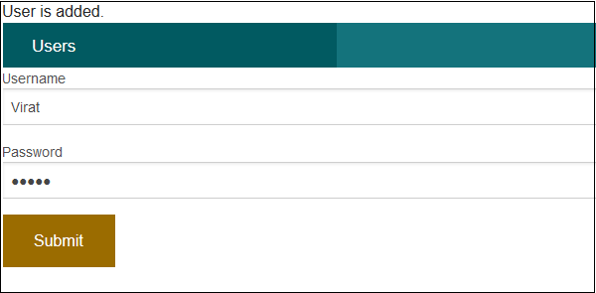

CakePHP - View a Record
To view records of database, we first need to get hold of a table using the TableRegistry class. We can fetch the instance out of registry using get() method. The get() method will take the name of the database table as argument. Now, this new instance is used to find records from database using find() method. This method will return all records from the requested table.

Example
Make changes in the config/routes.php file as shown in the following code.
config/routes.php
<?php
use Cake\Core\Plugin;
use Cake\Routing\RouteBuilder;
use Cake\Routing\Router;

Router::defaultRouteClass('DashedRoute');
Router::scope('/', function (RouteBuilder $routes) {
$routes->connect('/users', ['controller' => 'Users', 'action' => 'index']);
$routes->fallbacks('DashedRoute');
});
Plugin::routes();
Create a UsersController.php file at src/Controller/UsersController.php. Copy the following code in the controller file.
src/controller/UsersController.php
<?php
namespace App\Controller;
use App\Controller\AppController;
use Cake\ORM\TableRegistry;
use Cake\Datasource\ConnectionManager;

class UsersController extends AppController{
public function index(){
$users = TableRegistry::get('users');
$query = $users->find();
$this->set('results',$query);
}
}
?>
Create a directory Users at src/Template, ignore if already created, and under that directory create a View file called index.ctp. Copy the following code in that file.
src/Template/Users/index.ctp
<a href = "add">Add User</a>
<table>
<tr>
<td>ID</td>
<td>Username</td>
<td>Password</td>
<td>Edit</td>
<td>Delete</td>
</tr>

<?php
foreach ($results as $row):
echo "<tr><td>".$row->id."</td>";
echo "<td>".$row->username."</td>";
echo "<td>".$row->password."</td>";
echo "<td><a href = '".$this->Url->build
(["controller" => "Users","action"=>"edit",$row->id])."'>Edit</a></td>";

echo "<td><a href = '".$this->Url->build
(["controller" => "Users","action"=> "delete",$row->id])."'>Delete</a></td></tr>";
endforeach;
?>
</table>
Execute the above example by visiting the following URL.
http://localhost:85/CakePHP/users

Output
Upon execution, the above URL will give you the following output.
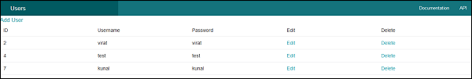

CakePHP - Update a Record
To update a record in database we first need to get hold of a table using TableRegistry class. We can fetch the instance out of registry using the get() method. The get() method will take the name of the database table as an argument. Now, this new instance is used to get particular record that we want to update.
Call the get() method with this new instance and pass the primary key to find a record which will be saved in another instance. Use this instance to set new values that you want to update and then finally call the save() method with the TableRegistry class’s instance to update record.

Example
Make changes in the config/routes.php file as shown in the following code.
config/routes.php
<?php
use Cake\Core\Plugin;
use Cake\Routing\RouteBuilder;
use Cake\Routing\Router;

Router::defaultRouteClass('DashedRoute');
Router::scope('/', function (RouteBuilder $routes) {
$routes->connect('/users/edit', ['controller' => 'Users', 'action' => 'edit']);
$routes->fallbacks('DashedRoute');
});
Plugin::routes();
Create a UsersController.php file at src/Controller/UsersController.php. Copy the following code in the controller file.
src/controller/UsersController.php
<?php
namespace App\Controller;
use App\Controller\AppController;
use Cake\ORM\TableRegistry;
use Cake\Datasource\ConnectionManager;

class UsersController extends AppController{
public function index(){
$users = TableRegistry::get('users');
$query = $users->find();
$this->set('results',$query);
}
public function edit($id){
if($this->request->is('post')){
$username = $this->request->data('username');
$password = $this->request->data('password');
$users_table = TableRegistry::get('users');
$users = $users_table->get($id);
$users->username = $username;
$users->password = $password;

if($users_table->save($users))
echo "User is udpated";
$this->setAction('index');
} else {
$users_table = TableRegistry::get('users')->find();
$users = $users_table->where(['id'=>$id])->first();
$this->set('username',$users->username);
$this->set('password',$users->password);
$this->set('id',$id);
}
}
}
?>
Create a directory Users at src/Template, ignore if already created, and under that directory create a view called index.ctp. Copy the following code in that file.
src/Template/Users/index.ctp
<a href = "add">Add User</a>
<table>
<tr>
<td>ID</td>
<td>Username</td>
<td>Password</td>
<td>Edit</td>
<td>Delete</td>
</tr>

<?php
foreach ($results as $row):
echo "<tr><td>".$row->id."</td>";
echo "<td>".$row->username."</td>";
echo "<td>".$row->password."</td>";
echo "<td><a href = '".$this->Url->build
(["controller" => "Users","action" => "edit",$row->id]).
"'>Edit</a></td>";
echo "<td><a href = '".$this->Url->build
(["controller" => "Users","action" => "delete",$row->id]).
"'>Delete</a></td></tr>";
endforeach;
?>
</table>
Create another View file under the Users directory called edit.ctp and copy the following code in it.
src/Template/Users/edit.ctp
<?php
echo $this->Form->create("Users",array('url'=>'/users/edit/'.$id));
echo $this->Form->input('username',['value'=>$username]);
echo $this->Form->input('password',['value'=>$password]);
echo $this->Form->button('Submit');
echo $this->Form->end();
?>
Execute the above example by visiting the following URL and click on Edit link to edit record.
http://localhost:85/CakePHP/users

Output
After visiting the above URL and clicking on the Edit link, you will receive the following output where you can edit record.
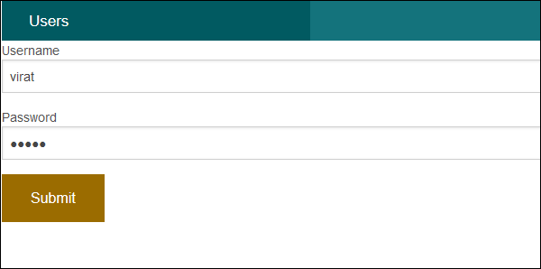

CakePHP - Delete a Record
To delete a record in database, we first need to get hold of a table using the TableRegistry class. We can fetch the instance out of registry using the get() method. The get() method will take the name of the database table as an argument. Now, this new instance is used to get particular record that we want to delete.
Call the get() method with this new instance and pass the primary key to find a record which will be saved in another instance. Use the TableRegistry class’s instance to call the delete method to delete record from database.

Example
Make changes in the config/routes.php file as shown in the following code.
config/routes.php
<?php
use Cake\Core\Plugin;
use Cake\Routing\RouteBuilder;
use Cake\Routing\Router;

Router::defaultRouteClass('DashedRoute');
Router::scope('/', function (RouteBuilder $routes) {
$routes->connect('/users/delete', ['controller' => 'Users', 'action' => 'delete']);
$routes->fallbacks('DashedRoute');
});
Plugin::routes();
Create a UsersController.php file at src/Controller/UsersController.php. Copy the following code in the controller file.
src/controller/UsersController.php
<?php
namespace App\Controller;
use App\Controller\AppController;
use Cake\ORM\TableRegistry;
use Cake\Datasource\ConnectionManager;

class UsersController extends AppController{
public function index(){
$users = TableRegistry::get('users');
$query = $users->find();
$this->set('results',$query);
}
public function delete($id){
$users_table = TableRegistry::get('users');
$users = $users_table->get($id);
$users_table->delete($users);
echo "User deleted successfully.";
$this->setAction('index');
}
}
?>
Just create an empty View file under Users directory called delete.ctp.
src/Template/Users/delete.ctp
Create a directory Users at src/Template, ignore if already created, and under that directory create a View file called index.ctp. Copy the following code in that file.
src/Template/Users/index.ctp
<a href = "add">Add User</a>
<table>
<tr>
<td>ID</td>
<td>Username</td>
<td>Password</td>
<td>Edit</td>
<td>Delete</td>
</tr>

<?php
foreach ($results as $row):
echo "<tr><td>".$row->id."</td>";
echo "<td>".$row->username."</td>";
echo "<td>".$row->password."</td>";
echo "<td><a href='".$this->Url->build
(["controller" => "Users","action" => "edit",$row->id])."'>Edit</a></td>";

echo "<td><a href='".$this->Url->build
(["controller" => "Users","action" -> "delete",$row->id])."'>Delete</a></td></tr>";
endforeach;
?>
</table>
Execute the above example by visiting the following URL and click on Delete link to delete record.
http://localhost:85/CakePHP/users

Output
After visiting the above URL and clicking on the Delete link, you will receive the following output where you can delete record.
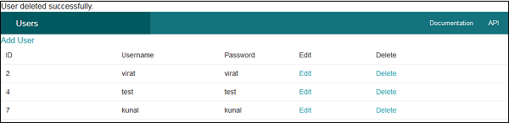

CakePHP - Services

Authentication
Authentication is the process of identifying the correct user. CakePHP supports three types of authentication.
- FormAuthenticate − It allows you to authenticate users based on form POST data. Usually this is a login form that users enter information into. This is default authentication method.
- BasicAuthenticate − It allows you to authenticate users using Basic HTTP authentication.
- DigestAuthenticate − It allows you to authenticate users using Digest HTTP authentication.

Example for FormAuthentication
Make changes in the config/routes.php file as shown in the following code.
config/routes.php
<?php
use Cake\Core\Plugin;
use Cake\Routing\RouteBuilder;
use Cake\Routing\Router;

Router::defaultRouteClass('DashedRoute');
Router::scope('/', function (RouteBuilder $routes) {
$routes->connect('/auth',['controller'=>'Authexs','action'=>'index']);
$routes->connect('/login',['controller'=>'Authexs','action'=>'login']);
$routes->connect('/logout',['controller'=>'Authexs','action'=>'logout']);
$routes->fallbacks('DashedRoute');
});
Plugin::routes();
Change the code of AppController.php file as shown in the following program.
src/Controller/AppController.php
<?php
namespace App\Controller;
use Cake\Controller\Controller;
use Cake\Event\Event;
use Cake\Controller\Component\AuthComponent;

class AppController extends Controller{
public function initialize(){
parent::initialize();

$this->loadComponent('RequestHandler');
$this->loadComponent('Flash');
$this->loadComponent('Auth', [
'authenticate' => [
'Form' => [
'fields' => ['username' => 'username', 'password' => 'password']
]
],
'loginAction' => ['controller' => 'Authexs', 'action' => 'login'],
'loginRedirect' => ['controller' => 'Authexs', 'action' => 'index'],
'logoutRedirect' => ['controller' => 'Authexs', 'action' => 'login']
]);

$this->Auth->config('authenticate', [
AuthComponent::ALL => ['userModel' => 'users'], 'Form']);
}

public function beforeRender(Event $event){
if (!array_key_exists('_serialize', $this=>viewVars) &&
in_array($this->response=>type(), ['application/json', 'application/xml'])) {
$this->set('_serialize', true);
}
}
}
Create AuthexsController.php file at src/Controller/AuthexsController.php. Copy the following code in the controller file.
src/Controller/AuthexsController.php
<?php
namespace App\Controller;
use App\Controller\AppController;
use Cake\ORM\TableRegistry;
use Cake\Datasource\ConnectionManager;
use Cake\Event\Event;
use Cake\Auth\DefaultPasswordHasher;

class AuthexsController extends AppController{
var $components = array('Auth');
public function index(){
}
public function login(){
if($this->request->is('post')){
$user = $this->Auth->identify();

if($user){
$this->Auth->setUser($user);
return $this->redirect($this->Auth->redirectUrl());
} else
$this->Flash->error('Your username or password is incorrect.');
}
}
public function logout(){
return $this->redirect($this->Auth->logout());
}
}
?>
Create a directory Authexs at src/Template and under that directory create a View file called login.ctp. Copy the following code in that file.
src/Template/Authexs/login.ctp
<?php
echo $this->Form->create();
echo $this->Form->input('username');
echo $this->Form->input('password');
echo $this->Form->button('Submit');
echo $this->Form->end();
?>
Create another View file called logout.ctp. Copy the following code in that file.
src/Template/Authexs/logout.ctp
You are successfully loggedout.
Create another View file called index.ctp. Copy the following code in that file.
src/Template/Authexs/index.ctp
You are successfully logged in.
<?php echo
$this->Html->link('logout',["controller" => "Authexs","action" => "logout"]);
?>
Execute the above example by visiting the following URL.
http://localhost:85/CakePHP/auth

Output
As the authentication has been implemented so once you try to visit the above URL, you will be redirected to the login page as shown below.
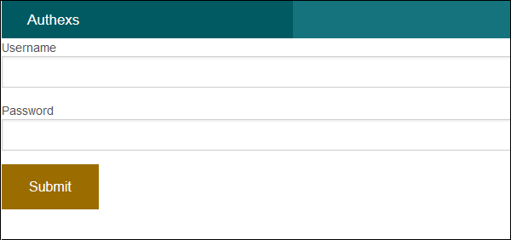
After providing the correct credentials, you will be logged in and redirected to the screen as shown below.
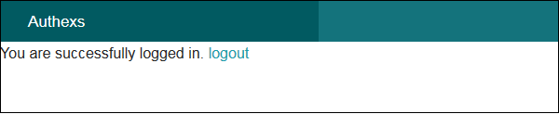
After clicking on the logout link, you will be redirected to the login screen again.

CakePHP - Errors and Exception Handling
Failure of system needs to be handled effectively for smooth running of the system. CakePHP comes with default error trapping that prints and logs error as they occur. This same error handler is used to catch Exceptions. Error handler displays errors when debug is true and logs error when debug is false. CakePHP has number of exception classes and the built in exception handling will capture any uncaught exception and render a useful page.

Errors and Exception Configuration
Errors and Exception can be configured in file config\app.php. Error handling accepts a few options that allow you to tailor error handling for your application −
Option | Data Type | Description
errorLevel | int | The level of errors you are interested in capturing. Use the built-in php error constants, and bitmasks to select the level of error you are interested in.
trace | bool | Include stack traces for errors in log files. Stack traces will be included in the log after each error. This is helpful for finding where/when errors are being raised.
exceptionRenderer | string | The class responsible for rendering uncaught exceptions. If you choose a custom class, you should place the file for that class in src/Error. This class needs to implement a render() method.
log | bool | When true, exceptions + their stack traces will be logged to Cake\Log\Log.
skipLog | array | An array of exception classnames that should not be logged. This is useful to remove NotFoundExceptions or other common, but uninteresting logs messages.
extraFatalErrorMemory | int | Set to the number of megabytes to increase the memory limit by when a fatal error is encountered. This allows breathing room to complete logging or error handling.

Example
Make changes in the config/routes.php file as shown in the following code.
config/routes.php
<?php
use Cake\Core\Plugin;
use Cake\Routing\RouteBuilder;
use Cake\Routing\Router;

Router::defaultRouteClass('DashedRoute');
Router::scope('/', function (RouteBuilder $routes) {
$routes->connect('/exception/:arg1/:arg2',[
'controller'=>'Exps','action'=>'index'],['pass' => ['arg1', 'arg2']]);
$routes->fallbacks('DashedRoute');
});
Plugin::routes();
Create ExpsController.php file at src/Controller/ExpsController.php. Copy the following code in the controller file.
src/Controller/ExpsController.php
<?php
namespace App\Controller;
use App\Controller\AppController;
use Cake\Core\Exception\Exception;

class ExpsController extends AppController{
public function index($arg1,$arg2){
try{
$this->set('argument1',$arg1);
$this->set('argument2',$arg2);

if(($arg1 < 1 || $arg1 > 10) || ($arg2 < 1 || $arg2 > 10))
throw new Exception("One of the number is out of range[1-10].");
}catch(\Exception $ex){
echo $ex->getMessage();
}
}
}
?>
Create a directory Exps at src/Template and under that directory create a View file called index.ctp. Copy the following code in that file.
src/Template/Exps/index.ctp
This is CakePHP tutorial and this is an example of Passed arguments.
Argument-1: <?=$argument1?>
Argument-2: <?=$argument2?>
Execute the above example by visiting the following URL.
http://localhost:85/CakePHP/exception/5/0

Output
Upon execution, you will receive the following output.
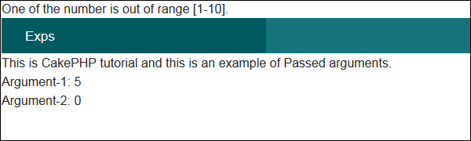

CakePHP - Logging
Logging in CakePHP is a very easy task. You just have to use one function. You can log errors, exceptions, user activities, action taken by users, for any background process like cronjob. Logging data in CakePHP is easy − the log() function is provided by the LogTrait, which is the common ancestor for almost all CakePHP classes.

Logging Configuration
We can configure the log in file config/app.php. There is a log section in the file where you can configure logging options as shown in the following screenshot.
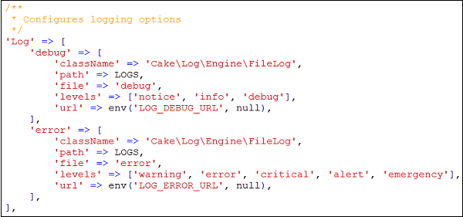
By default, you will see two log levels − error and debug already configured for you. Each will handle different level of messages.
CakePHP supports various logging levels as shown below −
- Emergency − System is unusable
- Alert − Action must be taken immediately
- Critical − Critical conditions
- Error − Error conditions
- Warning − Warning conditions
- Notice − Normal but significant condition
- Info − Informational messages
- Debug − Debug-level messages

Writing to Log file
There are two ways by which we can write in a Log file.
The first is to use the static write() method. The following is the syntax of the static write() method .
Syntax | write( integer|string $level , mixed $message , string|array $context[] )
Parameters | The severity level of the message being written. The value must be an integer or string matching a known level.  Message content to log.  Additional data to be used for logging the message. The special scope key can be passed to be used for further filtering of the log engines to be used. If a string or a numerically index array is passed, it will be treated as the scope key. See Cake\Log\Log::config() for more information on logging scopes.
Returns | boolean
Description | Writes the given message and type to all of the configured log adapters. Configured adapters are passed both the $level and $message variables. $level is one of the following strings/values.
The second is to use the log() shortcut function available on any using the LogTrait Calling log() will internally call Log::write()−

Example
Make changes in the config/routes.php file as shown in the following program.
config/routes.php
<?php
use Cake\Core\Plugin;
use Cake\Routing\RouteBuilder;
use Cake\Routing\Router;

Router::defaultRouteClass('DashedRoute');
Router::scope('/', function (RouteBuilder $routes) {
$routes->connect('logex',['controller'=>'Logexs','action'=>'index']);
$routes->fallbacks('DashedRoute');
});
Plugin::routes();
Create a LogexController.php file at src/Controller/LogexController.php. Copy the following code in the controller file.
src/Controller/LogexController.php
<?php
namespace App\Controller;
use App\Controller\AppController;
use Cake\Log\Log;

class LogexsController extends AppController{
public function index(){
/*The first way to write to log file.*/
Log::write('debug',"Something didn't work.");

/*The second way to write to log file.*/
$this->log("Something didn't work.",'debug');
}
}
?>
Create a directory Logexs at src/Template and under that directory create a View file called index.ctp. Copy the following code in that file.
src/Template/Logexs/index.ctp
Something is written in log file. Check log file logs\debug.log
Execute the above example by visiting the following URL.
http://localhost:85/CakePHP/logex

Output
Upon execution, you will receive the following output.
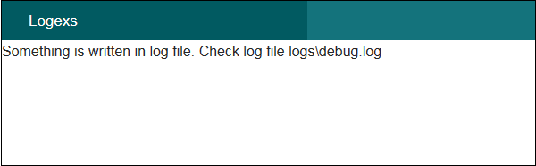

CakePHP - Form Handling
CakePHP provides various in built tags to handle HTML forms easily and securely. Like many other PHP frameworks, major elements of HTML are also generated using CakePHP. Following are the various functions used to generate HTML elements.
The following functions are used to generate select options.
Syntax | _selectOptions( array $elements array(), array $parents array(), boolean $showParents null, array $attributes array() )
Parameters | - Elements to format  - Parents for OPTGROUP  - Whether to show parents  - HTML attributes
Returns | array
Description | Returns an array of formatted OPTION/OPTGROUP elements
The following functions are used to generate HTML select element.
Syntax | select( string $fieldName, array $options array(), array $attributes array() )
Parameters | Name attribute of the SELECT  Array of the OPTION elements (as 'value'=>'Text' pairs) to be used in the SELECT element  The HTML attributes of the select element.
Returns | Formatted SELECT element
Description | Returns a formatted SELECT element
The following functions are used to generate button on HTML page.
Syntax | Button (string $title, array $options array() )
Parameters | - The button's caption. Not automatically HTML encoded.  - Array of options and HTML attributes.
Returns | HTML button tag.
Description | Creates a <button> tag. The type attribute defaults to type="submit". You can change it to a different value by using $options['type'].
The following functions are used to generate checkbox on HTML page.
Syntax | Checkbox (string $fieldName, array $options array() )
Parameters | - Name of a field, like this "Modelname.fieldname"  - Array of HTML attributes. Possible options are value, checked, hiddenField, disabled, default.
Returns | An HTML text input element.
Description | Creates a checkbox input widget.
The following functions are used to create form on HTML page.
Syntax | create( mixed $model null, array $options array() )
Parameters | - The model name for which the form is being defined. Should include the plugin name for plugin models. e.g. ContactManager.Contact. If an array is passed and $options argument is empty, the array will be used as options. If false no model is used.  - An array of html attributes and options. Possible options are type, action, url, default, onsubmit, inputDefaults, encoding
Returns | A formatted opening FORM tag.
Description | Returns an HTML FORM element.
The following functions are used to provide file uploading functionality on HTML page.
Syntax | file(string $fieldName, array $options array() )
Parameters | - Name of a field, in the form "Modelname.fieldname"  - Array of HTML attributes.
Returns | A generated file input.
Description | Creates file input widget.
The following functions are used to create hidden element on HTML page.
Syntax | hidden( string $fieldName, array $options array() )
Parameters | - Name of a field, in the form of "Modelname.fieldname"  - Array of HTML attributes.
Returns | A generated hidden input
Description | Creates a hidden input field
The following functions are used to generate input element on HTML page.
Syntax | Input (string $fieldName, array $options array() )
Parameters | - This should be "Modelname.fieldname"  - Each type of input takes different options
Returns | Completed form widget
Description | Generates a form input element complete with label and wrapper div
The following functions are used to generate radio button on HTML page.
Syntax | Radio (string $fieldName, array $options array(), array $attributesarray() )
Parameters | - Name of a field, like this "Modelname.fieldname"  - Radio button options array.  - Array of HTML attributes, and special attributes above.
Returns | Completed radio widget set
Description | Creates a set of radio widgets. Will create a legend and fieldset by default. Use $options to control this.
The following functions are used to generate submit button on HTML page.
Syntax | Submit (string $caption null, array $options array() )
Parameters | - The label appearing on the button OR if string contains :// or the extension .jpg, .jpe, .jpeg, .gif, .png use an image if the extension exists, AND the first character is /, image is relative to webroot, OR if the first character is not /, image is relative to webroot/img.  - Array of options. Possible options are div, before, after, type etc.
Returns | An HTML submit button
Description | Creates a submit button element. This method will generate <input/> elements that can be used to submit, and reset forms by using $options. Image submits can be created by supplying an image path for $caption.
The following functions are used to generate textarea element on HTML page.
Syntax | Textarea (string $fieldName, array $options array() )
Parameters | - Name of a field, in the form "Modelname.fieldname"  - Array of HTML attributes, special option like escape
Returns | A generated HTML text input element
Description | Creates a textarea widget

Example
Make changes in the config/routes.php file as shown in the following code.
config/routes.php
<?php
use Cake\Core\Plugin;
use Cake\Routing\RouteBuilder;
use Cake\Routing\Router;

Router::defaultRouteClass('DashedRoute');
Router::scope('/', function (RouteBuilder $routes) {
$routes->connect('register',['controller'=>'Registrations','action'=>'index']);
$routes->fallbacks('DashedRoute');
});
Plugin::routes();
Create a RegistrationController.php file at src/Controller/RegistrationController.php. Copy the following code in the controller file.
src/Controller/RegistrationController.php
<?php
namespace App\Controller;
use App\Controller\AppController;

class RegistrationsController extends AppController{
public function index(){
$country = array('India','United State of America','United Kingdom');
$this->set('country',$country);
$gender = array('Male','Female');
$this->set('gender',$gender);
}
}
?>
Create a directory Registrations at src/Template and under that directory create a View file called index.ctp. Copy the following code in that file.
src/Template/Registrations/index.ctp
<?php
echo $this->Form->create("Registrations",array('url'=>'/register'));
echo $this->Form->input('username');
echo $this->Form->input('password');
echo $this->Form->input('password');
echo '<label for="country">Country</label>';
echo $this->Form->select('country',$country);
echo '<label for="gender">Gender</label>';
echo $this->Form->radio('gender',$gender);
echo '<label for="address">Address</label>';
echo $this->Form->textarea('address');
echo $this->Form->file('profilepic');
echo '<div>'.$this->Form->checkbox('terms').
'<label for="country">Terms &Conditions</label></div>';
echo $this->Form->button('Submit');
echo $this->Form->end();
?>
Execute the above example by visiting the following URL − http://localhost:85/CakePHP/register

Output
Upon execution, you will receive the following output.
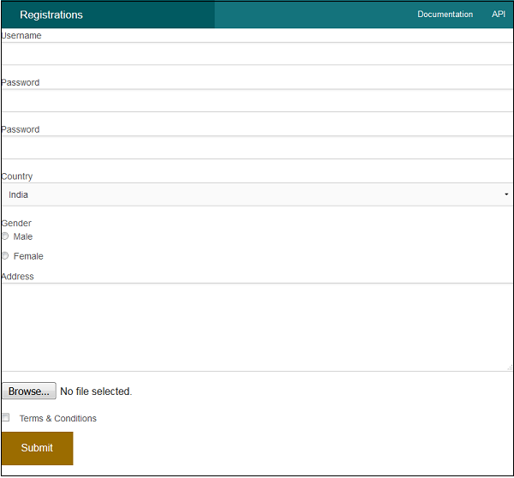

CakePHP - Session Management
Session allows us to manage unique users across requests and stores data for specific users. Session data can be accessible anywhere anyplace where you have access to request object, i.e., sessions are accessible from controllers, views, helpers, cells, and components.

Accessing Session Object
Session object can be created by executing the following code.
$session = $this->request->session();

Writing Session Data
To write something in session, we can use the write() session method.
Session::write($key, $value)
The above method will take two arguments, the value and the key under which the value will be stored.

Example
$session->write('name', 'Virat Gandhi');

Reading Session Data
To retrieve stored data from session, we can use the read() session method.
Session::read($key)
The above function will take only one argument that is the key of the value which was used at the time of writing session data. Once the correct key was provided then the function will return its value.

Example
$session->read('name');
When you want to check whether particular data exists in the session or not, then you can use the check() session method.
Session::check($key)
The above function will take only key as the argument.

Example
if ($session->check('name')) {
// name exists and is not null.
}

Delete Session Data
To delete data from session, we can use the delete() session method to delete the data.
Session::delete($key)
The above function will take only key of the value to be deleted from session.

Example
$session->delete('name');
When you want to read and then delete data from session then, we can use the consume() session method.
static Session::consume($key)
The above function will take only key as argument.

Example
$session->consume('name');

Destroying a Session
We need to destroy a user session when the user logs out from the site and to destroy the session the destroy() method is used.
Session::destroy()

Example
$session->destroy();
Destroying session will remove all session data from server but will not remove session cookie.

Renew a Session
In a situation where you want to renew user session then we can use the renew() session method.
Session::renew()

Example
$session->renew();

Complete Session
Make changes in the config/routes.php file as shown in the following program.
config/routes.php
<?php
use Cake\Core\Plugin;
use Cake\Routing\RouteBuilder;
use Cake\Routing\Router;

Router::defaultRouteClass('DashedRoute');
Router::scope('/', function (RouteBuilder $routes) {
$routes->connect('/sessionobject',
['controller'=>'Sessions','action'=>'index']);
$routes->connect('/sessionread',
['controller'=>'Sessions','action'=>'retrieve_session_data']);
$routes->connect('/sessionwrite',
['controller'=>'Sessions','action'=>'write_session_data']);
$routes->connect('/sessioncheck',
['controller'=>'Sessions','action'=>'check_session_data']);
$routes->connect('/sessiondelete',
['controller'=>'Sessions','action'=>'delete_session_data']);
$routes->connect('/sessiondestroy',
['controller'=>'Sessions','action'=>'destroy_session_data']);
$routes->fallbacks('DashedRoute');
});
Plugin::routes();
Create a SessionsController.php file at src/Controller/SessionsController.php. Copy the following code in the controller file.
src/Controller/SessionsController.php
<?php
namespace App\Controller;
use App\Controller\AppController;

class SessionsController extends AppController{
public function retrieveSessionData(){
//create session object
$session = $this->request->session();

//read data from session
$name = $session->read('name');
$this->set('name',$name);
}
public function writeSessionData(){
//create session object
$session = $this->request->session();

//write data in session
$session->write('name','Virat Gandhi');
}
public function checkSessionData(){
//create session object
$session = $this->request->session();

//check session data
$name = $session->check('name');
$address = $session->check('address');
$this->set('name',$name);
$this->set('address',$address);
}
public function deleteSessionData(){
//create session object
$session = $this->request->session();

//delete session data
$session->delete('name');
}
public function destroySessionData(){
//create session object
$session = $this->request->session();

//destroy session
$session->destroy();
}
}
?>
Create a directory Sessions at src/Template and under that directory create a View file called write_session_data.ctp. Copy the following code in that file.
src/Template/Sessions/write_session_data.ctp
The data has been written in session.
Create another View file called retrieve_session_data.ctp under the same Sessions directory and copy the following code in that file.
src/Template/Sessions/retrieve_session_data.ctp
Here is the data from session.
Name: <?=$name;?>
Create another View file called check_session_data.ctp under the same Sessions directory and copy the following code in that file.
src/Template/Sessions/check_session_data.ctp
<?php if($name): ?>
name exists in the session.

<?php else: ?>
name doesn't exist in the database

<?php endif;?>
<?php if($address): ?>
address exists in the session.

<?php else: ?>
address doesn't exist in the database

<?php endif;?>
Create another filbe View called delete_session_data.ctp under the same Sessions directory and copy the following code in that file.
src/Template/Sessions/delete_session_data.ctp
Data deleted from session.
Create another View file called destroy_session_data.ctp under the same Sessions directory and copy the following code in that file.
src/Template/Sessions/destroy_session_data.ctp
Session Destroyed.

Output
Execute the above example by visiting the following URL. This URL will help you write data in session.
http://localhost:85/CakePHP/session-write
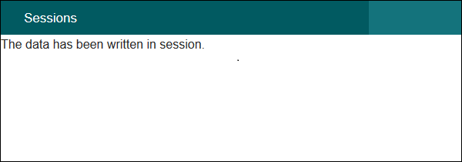
Visit the following URL to read session data − http://localhost:85/CakePHP/session-read
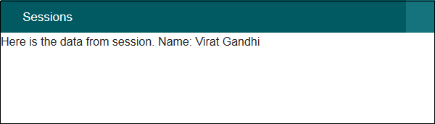
Visit the following URL to check session data − http://localhost:85/CakePHP/sessioncheck
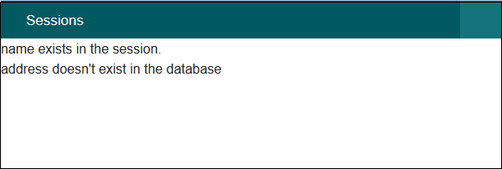
Visit the following URL to delete session data − http://localhost:85/CakePHP/sessiondelete
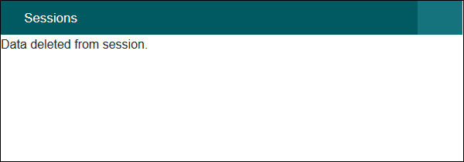
Visit the following URL to destroy session data − http://localhost:85/CakePHP/sessiondestroy
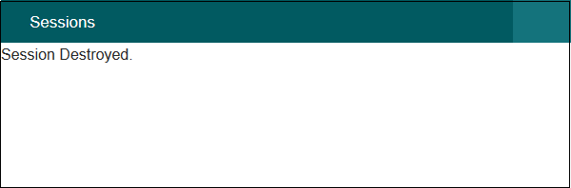

CakePHP - Cookie Management
Handling Cookie with CakePHP is easy and secure. There is a CookieComponent class which is used for managing Cookie. The class provides several methods for working with Cookies.

Write Cookie
The write() method is used to write cookie. Following is the syntax of the write() method.
Cake\Controller\Component\CookieComponent::write(mixed $key, mixed $value = null)
The write() method will take two arguments, the name of cookie variable ($key), and the value of cookie variable ($value).

Example
$this->Cookie->write('name', 'Virat');
We can pass array of name, values pair to write multiple cookies.

Read Cookie
The read() method is used to read cookie. Following is the syntax of the read() method.
Cake\Controller\Component\CookieComponent::read(mixed $key = null)
The read() method will take one argument, the name of cookie variable ($key).

Example
echo $this->Cookie->read('name');

Check Cookie
The check() method is used to check whether a key/path exists and has a non-null value. Following is the syntax of the check() method.
Cake\Controller\Component\CookieComponent::check($key)

Example
echo $this->Cookie->check(‘name’);

Delete Cookie
The delete() method is used to delete cookie. Following is the syntax of the delete() method.
Cake\Controller\Component\CookieComponent::delete(mixed $key)
The delete() method will take one argument, the name of cookie variable ($key) to delete.

Example 1
$this->Cookie->delete('name');

Example 2
Make changes in the config/routes.php file as shown in the following program.
config/routes.php
<?php
use Cake\Core\Plugin;
use Cake\Routing\RouteBuilder;
use Cake\Routing\Router;

Router::defaultRouteClass('DashedRoute');
Router::scope('/', function (RouteBuilder $routes) {
$routes->connect('cookie/write',['controller'=>'Cookies','action'=>'write_cookie']);
$routes->connect('cookie/read',['controller'=>'Cookies','action'=>'read_cookie']);
$routes->connect('cookie/check',['controller'=>'Cookies','action'=>'check_cookie']);
$routes->connect('cookie/delete',['controller'=>'Cookies','action'=>'delete_cookie']);
$routes->fallbacks('DashedRoute');
});
Plugin::routes();
Create a CookiesController.php file at src/Controller/CookiesController.php. Copy the following code in the controller file.
src/Controller/Cookies/CookiesController.php
<?php
namespace App\Controller;
use App\Controller\AppController;
use Cake\Controller\Component\CookieComponent;

class CookiesController extends AppController{
public $components = array('Cookie');

public function writeCookie(){
$this->Cookie->write('name', 'Virat');
}
public function readCookie(){
$cookie_val = $this->Cookie->read('name');
$this->set('cookie_val',$cookie_val);
}
public function checkCookie(){
$isPresent = $this->Cookie->check('name');
$this->set('isPresent',$isPresent);
}
public function deleteCookie(){
$this->Cookie->delete('name');
}
}
?>
Create a directory Cookies at src/Template and under that directory create a View file called write_cookie.ctp. Copy the following code in that file.
src/Template/Cookie/write_cookie.ctp
The cookie has been written.
Create another View file called read_cookie.ctp under the same Cookies directory and copy the following code in that file.
src/Template/Cookie/read_cookie.ctp
The value of the cookie is: <?php echo $cookie_val; ?>
Create another View file called check_cookie.ctp under the same Cookies directory and copy the following code in that file.
src/Template/Cookie/check_cookie.ctp
<?php
if($isPresent):
?>
The cookie is present.

<?php
else:
?>
The cookie isn't present.

<?php
endif;
?>
Create another View file called delete_cookie.ctp under the same Cookies directory and copy the following code in that file.
src/Template/Cookie/delete_cookie.ctp
The cookie has been deleted.

Output
Execute the above example by visiting the following URL − http://localhost:85/CakePHP/cookie/write
This will help you write data in cookie.
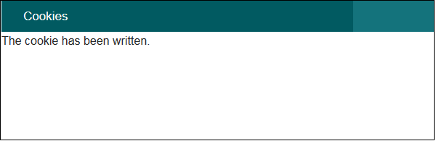
Visit the following URL to read cookie data − http://localhost:85/CakePHP/cookie/read
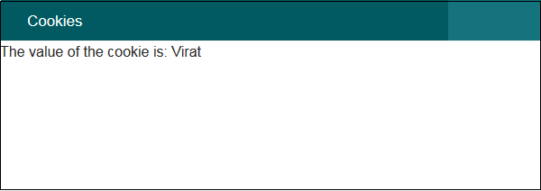
Visit the following URL to check cookie data − http://localhost:85/CakePHP/cookie/check
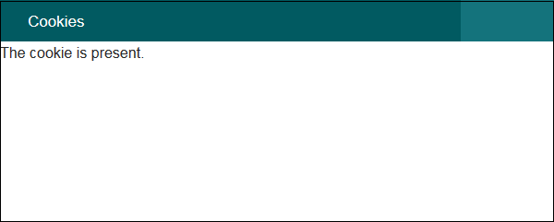
Visit the following URL to delete cookie data − http://localhost:85/CakePHP/cookie/delete
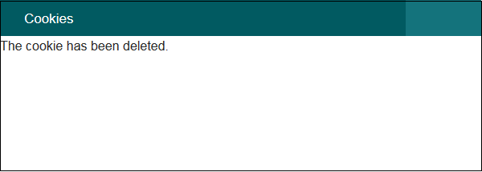

CakePHP - Security
Security is another important feature while building web applications. It assures the users of the website that their data is secured. CakePHP provides some tools to secure your application.

Encryption and Decryption
Security library in CakePHP provides methods by which we can encrypt and decrypt data. Following are the two methods which are used for the same purpose.
static Cake\Utility\Security::encrypt($text, $key, $hmacSalt = null)
static Cake\Utility\Security::decrypt($cipher, $key, $hmacSalt = null)
The encrypt method will take text and key as the argument to encrypt data and the return value will be the encrypted value with HMAC checksum.
To hash a data hash() method is used. Following is the syntax of the hash() method.

Syntax
static Cake\Utility\Security::hash($string, $type = NULL, $salt = false)

CSRF
CSRF stands for Cross Site Request Forgery. By enabling the CSRF Component, you get protection against attacks. CSRF is a common vulnerability in web applications. It allows an attacker to capture and replay a previous request, and sometimes submit data requests using image tags or resources on other domains. The CSRF can be enabled by simply adding the CsrfComponent to your components array as shown below.
public function initialize(){
parent::initialize();
$this->loadComponent('Csrf');
}
The CsrfComponent integrates seamlessly with FormHelper. Each time you create a form with FormHelper, it will insert a hidden field containing the CSRF token.
While this is not recommended, you may want to disable the CsrfComponent on certain requests. You can do so by using the controller’s event dispatcher, during the beforeFilter() method.
public function beforeFilter(Event $event){
$this->eventManager()->off($this->Csrf);
}

Security Component
Security Component applies tighter security to your application. It provides methods for various tasks like −
- Restricting which HTTP methods your application accepts − You should always verify the HTTP method being used before executing side-effects. You should check the HTTP method or use Cake\Network\Request::allowMethod() to ensure the correct HTTP method is used.
- Form tampering protection − By default, the SecurityComponent prevents users from tampering with forms in specific ways. The SecurityComponent will prevent the following things −
  - Unknown fields cannot be added to the form.
  - Fields cannot be removed from the form.
  - Values in hidden inputs cannot be modified.
- Requiring that SSL be used − all actions to require a SSL-secured.
- Limiting cross controller communication − We can restrict which controller can send request to this controller. We can also restrict which actions can send request to this controller’s action.

Example
Make changes in the config/routes.php file as shown in the following program.
config/routes.php
<?php
use Cake\Core\Plugin;
use Cake\Routing\RouteBuilder;
use Cake\Routing\Router;

Router::defaultRouteClass('DashedRoute');
Router::scope('/', function (RouteBuilder $routes) {
$routes->connect('login',['controller'=>'Logins','action'=>'index']);
$routes->fallbacks('DashedRoute');
});
Plugin::routes();
Create a LoginsController.php file at src/Controller/LoginsController.php. Copy the following code in the controller file.
src/Controller/LoginsController.php
<?php
namespace App\Controller;
use App\Controller\AppController;

class LoginsController extends AppController{
public function initialize(){
parent::initialize();
$this->loadComponent('Security');
}
public function index(){
}
}
?>
Create a directory Logins at src/Template and under that directory create a View file called index.ctp. Copy the following code in that file.
src/Template/Logins/index.ctp
<?php
echo $this->Form->create("Logins",array('url'=>'/login'));
echo $this->Form->input('username');
echo $this->Form->input('password');
echo $this->Form->button('Submit');
echo $this->Form->end();
?>
Execute the above example by visiting the following URL −http://localhost:85/CakePHP/login

Output
Upon execution, you will receive the following output.
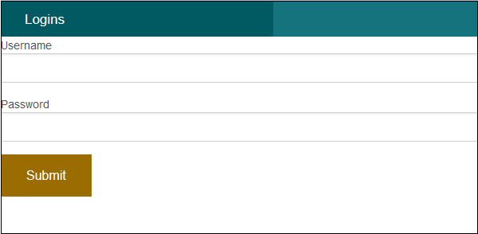

CakePHP - Validation
Often while making websites we need to validate certain things before processing data further. CakePHP provides validation package to build validators that can validate data with ease.

Validation Methods
CakePHP provides various validation methods in the Validation Class. Some of the most popular of them are listed below.
Syntax | Add (string $field, array|string $name, array|Cake\Validation\ValidationRule $rule [] )
Parameters | - The name of the field from which the rule will be added.  - The alias for a single rule or multiple rules array.  - The rule to add
Returns | $this
Description | Adds a new rule to a field's rule set. If second argument is an array, then rules list for the field will be replaced with second argument and third argument will be ignored.
Syntax | allowEmpty (string $field, boolean|string|callable $when true, string|null $message null)
Parameters | - The name of the field.  - Indicates when the field is allowed to be empty. Valid values are true (always), 'create', 'update'. If a callable is passed, then the field will be left empty only when the callback returns true.  - The message to show if the field is not.
Returns | $this
Description | Allows a field to be empty.
Syntax | alphanumeric (string $field, string|null $message null, string|callable|null $when null)
Parameters | - The field you want to apply the rule to.  - The error message when the rule fails.  - Either 'create' or 'update' or a callable that returns true when the validation rule should be applied.
Returns | $this
Description | Add an alphanumeric rule to a field.
Syntax | creditCard (string $field, string $type 'all', string|null $message null, string|callable|null $when null)
Parameters | - The field you want to apply the rule to.  - The type of cards you want to allow. Defaults to 'all'. You can also supply an array of accepted card types, for example, ['mastercard', 'visa', 'amex'].  - The error message when the rule fails.  - Either 'create' or 'update' or a callable that returns true when the validation rule should be applied.
Returns | $this
Description | Add a credit card rule to a field.
Syntax | Email (string $field, boolean $checkMX false, string|null $message null, string|callable|null $when null)
Parameters | - The field you want to apply the rule to.  - Whether or not to check the MX records.  - The error message when the rule fails.  - Either 'create' or 'update' or a callable that returns true when the validation rule should be applied.
Returns | $this
Description | Add an email validation rule to a field.
Syntax | maxLength (string $field, integer $max, string|null $message null, string|callable|null $when null)
Parameters | - The field you want to apply the rule to.  - The maximum length allowed.  - The error message when the rule fails.  - Either 'create' or 'update' or a callable that returns true when the validation rule should be applied.
Returns | $this
Description | Add a string length validation rule to a field.
Syntax | minLength (string $field, integer $min, string|null $message null, string|callable|null $when null)
Parameters | - The field you want to apply the rule to.  - The maximum length allowed.  - The error message when the rule fails.  - Either 'create' or 'update' or a callable that returns true when the validation rule should be applied.
Returns | $this
Description | Add a string length validation rule to a field.
Syntax | notBlank (string $field, string|null $message null, string|callable|null $when null)
Parameters | - The field you want to apply the rule to.  - The error message when the rule fails.  - Either 'create' or 'update' or a callable that returns true when the validation rule should be applied.
Returns | $this
Description | Add a notBlank rule to a field.

CakePHP - Creating Validators
Validator can be created by adding the following two lines in the controller.
use Cake\Validation\Validator;
$validator = new Validator();

Validating Data
Once we have created validator, we can use the validator object to validate data. The following code explains how we can validate data for login webpage.
$validator->notEmpty('username', 'We need username.')->add('username',
'validFormat', ['rule' => 'email','message' => 'E-mail must be valid']);

$validator->notEmpty('password', 'We need password.');
$errors = $validator->errors($this->request->data());
Using the $validator object we have first called the notEmpty() method which will ensure that the username must not be empty. After that we have chained the add() method to add one more validation for proper email format.
After that we have added validation for password field with notEmpty() method which will confirms that password field must not be empty.

Example
Make Changes in the config/routes.php file as shown in the following program.
config/routes.php
<?php
use Cake\Core\Plugin;
use Cake\Routing\RouteBuilder;
use Cake\Routing\Router;

Router::defaultRouteClass('DashedRoute');
Router::scope('/', function (RouteBuilder $routes) {
$routes->connect('validation',['controller'=>'Valids','action'=>'index']);
$routes->fallbacks('DashedRoute');
});
Plugin::routes();
Create a ValidsController.php file at src/Controller/ValidsController.php. Copy the following code in the controller file.
src/Controller/ValidsController.php
<?php
namespace App\Controller;
use App\Controller\AppController;
use Cake\Validation\Validator;

class ValidsController extends AppController{
public function index(){
$validator = new Validator();
$validator->notEmpty('username', 'We need username.')
->add('username', 'validFormat', ['rule' => 'email','message'
=> 'E-mail must be valid']);

$validator->notEmpty('password', 'We need password.');
$errors = $validator->errors($this->request->data());
$this->set('errors',$errors);
}
}
?>
Create a directory Valids at src/Template and under that directory create a View file called index.ctp. Copy the following code in that file.
src/Template/Valids/index.ctp
<?php
if($errors){
foreach($errors as $error)
foreach($error as $msg)

echo '<font color = "red">'.$msg.'</font>l';
} else {
echo "No errors.";
}

echo $this->Form->create("Logins",array('url'=>'/validation'));
echo $this->Form->input('username');
echo $this->Form->input('password');
echo $this->Form->button('Submit');
echo $this->Form->end();
?>
Execute the above example by visiting the following URL −http://localhost:85/CakePHP/validation

Output
Click on the submit button without entering anything. You will receive the following output.
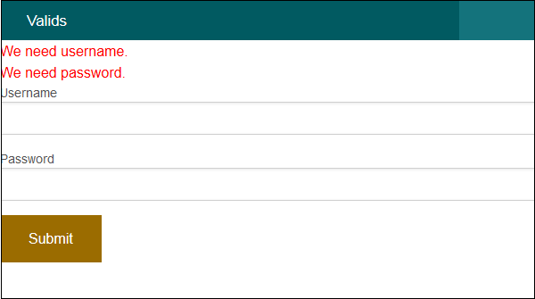

CakePHP 3 Tutorial 1: Application setup
Submitted by naidim on Mon, 09/26/2016 - 06:55
When I learn new things, I like to document what I'm doing to reiterate to myself what I've learned, to keep track of my process and catch errors, and maybe even help someone else. This is my tutorial on building a CakePHP 3 framework application.
I've been working with CakePHP since version 1.3 and I find its rapid scaffolding and quick development a godsend in my work where I have to do the jobs of multiple people. "Less with more" as they keep saying. CakePHP uses "convention over configuration." What this means is that once you understand the conventions, so much of the CakePHP functionality is automatic, saving immense amounts of time.
I'm using a typical LAMP stack on CentOS 7, Apache 2.4, MariaDB 5.5 with PHP 7.0 from the Remi repository. Any other stack will use similar if not identical code.

1: Create your database, setting up a username and password.

2: Install the CakePHP application.
$ composer create-project --prefer-dist cakephp/app [application-name]
This will create the application in a directory of the same name as the application. All future paths will be based on the application root in that directory so assume you are in that directory after this point.

3: Configure CakePHP to communicate with your database.
Edit your applications config/app.php file and change the Datasources configuration to match your database settings. To verify that your connection is working, browse to your application directory using your web browser (e.g. http://localhost/application-name ) and you should see a configuration verification page.

4: Optional Configuration
In addition to the datasource configuration, there are other options in the config/app.php file. The first one to be aware of is the security "salt." The idea of a cryptographic "salt" is that the same password, or other value, encrypted in two places, doesn't end up with the same encrypted value. You may have even seen a warning on the configuration verification page recommending updating your salt. Update the salt to any random 64 characters. During the installation process CakePHP sets a unique salt for you, though you may want to adjust it to add more randomness.
Another setting is the Session. CakePHP by default uses standard PHP sessions, but you can configure this to use a database for when you have a load-balanced application across multiple servers for example. Some handy options for the session are to set your own timeout. I'm unsure what the default is but it is less than I need to prevent annoying my users. Also a good idea is to set your cookie name unique to other applications so users don't share the same cookie if you have multiple applications on the same server. Below is an example configuration:
'Session' => [
'defaults' => 'php',
'timeout' => 12 * 60, //in minutes
'cookie' => 'application-name',
],
Now the basic application is set up and we can start building the data and interface functionality.

CakePHP 3 Tutorial 2: Database and Model
Submitted by naidim on Mon, 09/26/2016 - 07:36
Now that your application is up and running, it is time to build your data store and interface with that data.

1: Create your database table.
Most applications require some form of user authentication and identification. To begin, set up your database table. The fields are mostly self-explanatory, however, the passkey and timeout fields are part of a password reset functionality that I add to save myself time later on as users constantly forget their passwords.
CREATE TABLE `users` (
`id` bigint(11) NOT NULL,
`username` varchar(15) COLLATE utf8mb4_unicode_ci NOT NULL,
`password` varchar(61) COLLATE utf8mb4_unicode_ci NOT NULL,
`email` varchar(50) COLLATE utf8mb4_unicode_ci NOT NULL,
`first_name` varchar(30) COLLATE utf8mb4_unicode_ci NOT NULL,
`last_name` varchar(30) COLLATE utf8mb4_unicode_ci NOT NULL,
`role` varchar(8) COLLATE utf8mb4_unicode_ci NOT NULL,
`passkey` varchar(13) COLLATE utf8mb4_unicode_ci NOT NULL,
`timeout` timestamp NULL DEFAULT NULL,
`modified` datetime NOT NULL,
`created` datetime NOT NULL
) ENGINE=InnoDB DEFAULT CHARSET=utf8mb4 COLLATE=utf8mb4_unicode_ci;
Once your table is created, you could use the built-in cake command line scripting to "bake" your Model, Views, and Controller. This will again save you a lot of time, however, you won't learn much if all I covered was bin/cake bake all users. Just know that that feature is available and is covered thoroughly in the CakePHP documentation: http://book.cakephp.org/3.0/en/index.html and all the code here is based on the basic baked templates.
The CakePHP Model is how the application interacts with the database table. There should be one model per table. For our users table you need to create 2 files: One named UsersTable.php that is located in the application/src/Model/Table/ directory and one named User.php located in the application/src/Model/Entity/ directory. If you do not have a model for a table, CakePHP will dynamically create a model for you with basic functionality.

2: Create Table Class
Table objects are used to interface with collections of objects, (i.e. tables). While much of the following class is self-explanatory, I've added some comments to clarify some of the lines below.
<?php
namespace App\Model\Table;

use Cake\ORM\Query;
use Cake\ORM\RulesChecker;
use Cake\ORM\Table;
use Cake\Validation\Validator;

class UsersTable extends Table
{
public function initialize(array $config)
{
parent::initialize($config);

$this->table('users'); // Name of the table in the database, if absent convention assumes lowercase version of file prefix
$this->displayField('full_name'); // field or virtual field used for default display in associated models, if absent 'id' is assumed
$this->primaryKey('id'); // Primary key field(s) in table, if absent convention assumes 'id' field

$this->addBehavior('Timestamp'); // Allows your model to timestamp records on creation/modification
}
}

3: Create Entity Class
Entity provide interface to individual objects (i.e. rows or records)
<?php
namespace App\Model\Entity;

use Cake\ORM\Entity;
use Cake\Auth\DefaultPasswordHasher;

class User extends Entity
{
// Fields that can be mass assigned using newEntity() or patchEntity();
protected $_accessible = [
'*' => true,
'id' => false
];
protected $_hidden = [ 'password' ]; // Fields excluded from JSON versions of the entity
// Hash the user's password before saving and before validation
protected function _setPassword($value)
{
$hasher = new DefaultPasswordHasher();
return $hasher->hash($value);
}
}

CakePHP 3 Tutorial 3: Validation
Submitted by naidim on Mon, 09/26/2016 - 08:19
Now we're going to update our Model to be more useful with more advanced Validation.

1: Basic Data Validation
As part of the database interface, the Model also performs data validation. There are many basic rules implemented into CakePHP by default, but you can also add as complex a custom rule as you would like.
Add the following to the src/Model/Table/UsersTable.php
public function validationDefault(Validator $validator)
{
$validator
->integer('id')
->allowEmpty('id', 'create'); // id field is not required when creating a new user
$validator
->requirePresence('username', 'create')
->notEmpty('username')
->add('username', 'unique', ['rule' => 'validateUnique', 'provider' => 'table']);
$validator
->requirePresence('password', 'create')
->notEmpty('password', 'You must enter a password', 'create')
->add('password', [
'length' => [
'rule' => ['minLength', 8],
'message' => 'Passwords must be at least 8 characters long.',
]
]);
$validator
->requirePresence('first_name', 'create')
->notEmpty('first_name');
$validator
->requirePresence('last_name', 'create')
->notEmpty('last_name');
$validator
->email('email')
->requirePresence('email', 'create')
->notEmpty('email');
$validator
->requirePresence('role', 'create')
->notEmpty('role');
$validator
->dateTime('timeout')
->allowEmpty('timeout');
return $validator;
}
public function buildRules(RulesChecker $rules)
{
$rules->add($rules->isUnique(['username']));
$rules->add($rules->isUnique(['email']));
return $rules;
}

2: Complex Validation
More complex validation is performed within the model with either CakePHP built in functionality (e.g. comparing two values) or custom functions.
A common validation functional when creating users is to enter the password twice to ensure the confirmation of the correct value being entered. With CakePHP this is easily accomplished with a temporary virtual field ("confirm_password") and the compareWith rule.
Add the following validator to the above validationDefault function:
$validator
->requirePresence('confirm_password', 'create')
->notEmpty('confirm_password')
->allowEmpty('confirm_password', 'update')
->add('confirm_password', 'compareWith', [
'rule' => ['compareWith', 'password'],
'message' => 'Passwords do not match.'
]);
Another common validation is to require secure passwords. We already have an 8 character requirement above, but we should at least follow the 8/4 rule.
Add the following function and update the validator for the password field:
/**
* Checks password for a single instance of each:
* number, uppercase, lowercase, and special character
*
* @param type $password
* @param array $context
* @return boolean
*/
public function checkCharacters($password, array $context)
{
// number
if (!preg_match("#[0-9]#", $password)) {
return false;
}
// Uppercase
if (!preg_match("#[A-Z]#", $password)) {
return false;
}
// lowercase
if (!preg_match("#[a-z]#", $password)) {
return false;
}
// special characters
if (!preg_match("#\W+#", $password) ) {
return false;
}
return true;
}
$validator
->requirePresence('password', 'create')
->notEmpty('password', 'You must enter a password', 'create')
->add('password', [
'length' => [
'rule' => ['minLength', 8],
'message' => 'Passwords must be at least 8 characters long.',
]
])
->add('password', 'custom', [
'rule' => [$this, 'checkCharacters'],
'message' => 'The password must contain 1 number, 1 uppercase, 1 lowercase, and 1 special character'
]);

3: Multiple Datasources
By default CakePHP uses the "default" database connection configuration for all database communication. If, however, you want to use multiple data stores, for example an Oracle and a MySql database, or 2 different MySql databases, you need to identify the connection when it isn't "default." To configure your model to always use a different datasource, add the following function to the model. Also be sure to have configured the alternate datasource in your config/app.php file.
/**
* Set connection to use users datasource
* @return string
*/
public static function defaultConnectionName()
{
return 'oracle';
}

CakePHP 3 Tutorial 4: Controller and Views
Submitted by naidim on Mon, 09/26/2016 - 09:31
Now we'll build our Controller to retrieve the data and some Views to display it.
While the Model is used for database interactions, the Controller is used for data requests and processing. While some developers prefer light controllers and others light models, I prefer to think of the controller as the workhorse between data storage/retrieval (the Model) and data display (the View), as it is easier for me wrap my head around that level of separation. As always, use what you think is the best tool for the job and try to do what makes sense to you, as you typically will be the person trying to debug your code in a year or three.
A simple controller contains the primary CRUD (Create/Read/Update/Delete) functions and requests the model to execute those tasks.

1: Build A Basic Controller
For our users table a simple controller would be src/Controller/UsersController.php and can look like this:
<?php
namespace App\Controller;

use App\Controller\AppController;

class UsersController extends AppController
{
private $roles = ['User' => 'User', 'Admin' => 'Admin', 'Disabled' => 'Disabled'];
public $paginate = [
'limit' => 30,
'order' => ['first_name' => 'ASC', 'last_name' => 'ASC']
];
public function index() {
$users = $this->paginate($this->Users);
$this->set(compact('users'));
$this->set('_serialize', ['users']);
}
public function view($id = null) {
$user = $this->Users->get($id);
$this->set('user', $user);
$this->set('_serialize', ['user']);
}
public function add() {
$user = $this->Users->newEntity();
if ($this->request->is('post')) {
$user = $this->Users->patchEntity($user, $this->request->data);
if ($this->Users->save($user)) {
$this->Flash->success(__('The user has been saved.'));
return $this->redirect(['action' => 'index']);
} else {
$this->Flash->error(__('The user could not be saved. Please, try again.'));
}
}
$roles = $this->roles;
$this->set(compact('user', 'roles'));
$this->set('_serialize', ['user']);
}
public function edit($id = null) {
$user = $this->Users->get($id);
if ($this->request->is(['patch', 'post', 'put'])) {
if ($this->request->data['password'] == '') {
unset($this->request->data['password']); // unset the blank password
}
$user = $this->Users->patchEntity($user, $this->request->data);
if ($this->Users->save($user)) {
$this->Flash->success(__('The user has been saved.'));
return $this->redirect(['action' => 'index']);
} else {
$this->Flash->error(__('The user could not be saved. Please, try again.'));
}
}
unset($user->password); // Unset the password so nothing is loaded or displayed in the form
$roles = $this->roles;
$this->set(compact('user', 'roles'));
$this->set('_serialize', ['user']);
}
public function delete($id = null) {
$this->request->allowMethod(['post', 'delete']);
$user = $this->Users->get($id);
if ($this->Users->delete($user)) {
$this->Flash->success(__('The user has been deleted.'));
} else {
$this->Flash->error(__('The user could not be deleted. Please, try again.'));
}
return $this->redirect(['action' => 'index']);
}
}
The roles array is the list of available roles, the values to be displayed and the keys to be stored in the records. The paginate variable overrides the default limit of 20 which I find too small, and setting the sort order. You cannot use virtual fields, such as full_name, to sort paginated lists, but you can define your sort order to be the same as the virtual field. There is a small issue with this in the View, but we'll cover that later.
You may have noticed in the edit() function we unset() the password field twice. First (listed second) we unset it before display so that the password field can remain blank. The hashed value that is stored in the database isn't useful for editing the user.
The second time is within the submission check. If the user has not set a new password, we don't want to save a null string to the database, overriding the current password.

2: Create the Index View
A common function is to list all records in a table for quick perusal. The index function is the default for this in CakePHP, and with Cake's default pagination it is quite easy to set up the view for this display.
Create the file index.ctp in the src/Template/Users/ directory. CakePHP uses the .ctp extension (CakePHP Template) for Views and Elements.
<?php if (empty($_GET['direction'])) { $this->Paginator->options(['url' => ['direction' => null, 'sort' => null]]); } ?>
<div class="users index large-9 medium-8 columns content">
<?php echo $this->Html->link(__('New User'), ['action' => 'add'], ['class' => 'right']); ?>
<h3><?php echo __('Users') ?></h3>
<table cellpadding="0" cellspacing="0">
<thead>
<tr>
<th><?php echo $this->Paginator->sort('first_name', 'Name') ?></th>
<th><?php echo $this->Paginator->sort('username') ?></th>
<th><?php echo $this->Paginator->sort('email') ?></th>
<th><?php echo $this->Paginator->sort('role') ?></th>
<th class="actions"><?php echo __('Actions') ?></th>
</tr>
</thead>
<tbody>
<?php foreach ($users as $user): ?>
<tr>
<td><?php echo $this->Html->link($user->full_name, ['action' => 'view', $user->id]) ?></td>
<td><?php echo h($user->username) ?></td>
<td><?php echo $this->Text->autoLinkEmails($user->email) ?></td>
<td><?php echo h($user->role) ?></td>
<td class="actions">
<?php echo $this->Html->link(__('View'), ['action' => 'view', $user->id]) ?> |
<?php echo $this->Html->link(__('Edit'), ['action' => 'edit', $user->id]) ?>
</td>
</tr>
<?php endforeach; ?>
</tbody>
</table>
<div class="paginator">
<ul class="pagination">
<?php echo $this->Paginator->prev('< ' . __('previous')) ?>
<?php echo $this->Paginator->numbers() ?>
<?php echo $this->Paginator->next(__('next') . ' >') ?>
</ul>
<p>page <?php echo $this->Paginator->counter() ?></p>
</div>
</div>
Sadly between CakePHP 2 and 3 the change to the data model has disabled the ability to sort on virtual fields (e.g. full_name) so you'll notice the header of the first column is 'first_name' not 'full_name'. In addition, the sort order is now passed via URL whether a sort order has been selected or not, losing our default sort of first_name and last_name. That's the purpose of the first line of the file: clearing the sort and direction options unless they have been explicitly selected.

3: Create Add View
To add a new user, we need src/Template/Users/add.ctp.
<?php $this->assign('title', 'Add User'); // Set the title for the page ?>
<div class="users form large-9 medium-8 columns content">
<?php echo $this->Form->create($user) ?>
<fieldset>
<legend><?php echo __('Add User') ?></legend>
<?php
echo $this->Form->input('username', ['autofocus' => true]);
echo $this->Form->input('first_name');
echo $this->Form->input('last_name');
echo $this->Form->input('password'); ?>
<p class="helper">Passwords must be at least 8 characters and contain at least 1 number, 1 uppercase, 1 lowercase and 1 special character</p>
<?php
echo $this->Form->input('confirm_password', ['type' => 'password']);
echo $this->Form->input('email');
echo $this->Form->input('role');
?>
</fieldset>
<?php echo $this->Form->button(__('Submit')); ?>
<?php echo $this->Html->link(__('Cancel'), ['action' => 'index'], ['class' => 'button']); ?>
<?php echo $this->Form->end(); ?>
</div>
The CakePHP Form helper easily creates a lot of the form fields for you based on the database field type. In some cases, such as the role field, it realizes there is an array named $roles and creates a select field utilizing that array. Since confirm_password is not a field in the database, it defaults to a text field, so utilizing the $options array you can tell Cake to render it as a password field.
At this point we can go to our application in the browser and add a user at http://localhost/application/users/add

CakePHP 3 Tutorial 5: Authentication
Submitted by naidim on Mon, 09/26/2016 - 09:32
Now that we have a user, complete with username and password, we can add authentication to restrict access to our application.

1: Add Authentication
The Application Controller in src/Controller/AppController.php is the parent class of all our controllers. In that file we want to add the Auth component that handles all the authentication. While we're editing that file it's a good idea to add the CSRF component to add tokens to our forms helping mitigate cross-site scripting attacks.
Edit the Application Controller and in the initialize() function under $this->loadComponent('Flash'); add:
$this->loadComponent('Csrf');
$this->loadComponent('Auth', [
'authorize' => 'Controller',
'unauthorizedRedirect' => $this->referer(),
]);
$this->Auth->allow(['display', 'password', 'reset', 'logout']); // Allow everyone access to specific actions
There are a lot of options for the Auth component that make things much more configurable, such as using the email field for the username, but for now we'll stick with the default settings and allow a few functions for usability. You can find these options at http://book.cakephp.org/3.0/en/controllers/components/authentication.ht…
As the parent class, the Application Controller controls who is authorized and who is not for all classes. The default setting is a logged in user is authorized everywhere, anonymous users are not. To change this we add the isAuthorized() function to src/Controller/AppController.php.
public function isAuthorized($user)
{
if (in_array($user['role'], ['Admin', 'User']) { // Don't give any access to "Disabled" user accounts
return true;
}
return false;
}
At this point you'll find you cannot access the application via browser at /users/index or /users/add.

2: Add Login Function and View
In order to log in you'll need a login() function in the Users Controller and the appropriate View.
Edit src/Controller/UsersController.php and add the following function:
public function login()
{
if ($this->request->is('post')) {
$user = $this->Auth->identify();
if ($user && $user['role'] != 'Disabled') { // Don't allow "Disabled" users to log in
$this->Auth->setUser($user);
return $this->redirect($this->Auth->redirectUrl());
}
$this->Flash->error('Your username or password is incorrect.');
}
}
Now create src/Template/Users/login.ctp The default page title is the current Model (e.g. "Users"), and while this may be good for some pages, for others you may want more descriptive page titles. The first line shows how you assign titles in the view.
<?php $this->assign('title', 'Login'); ?>
<div class="users form">
<?php echo $this->Form->create() ?>
<fieldset>
<legend>
<?php echo $this->Form->input('username', ['required' => true, 'autofocus' => true]) ?>
<?php echo $this->Form->input('password', ['required' => true]) ?>
<?php echo $this->Html->link(__('Forgot Password?'), ['action' => 'password']) ?>
</fieldset>
<?php echo $this->Form->button(__('Login')); ?>
<?php echo $this->Form->end() ?>
</div>
And now you can log in at http://localhost/application/users/login and if you aren't logged in any other page request will redirect you to that page.

CakePHP 3 Tutorial 6: Sessions
Submitted by naidim on Mon, 09/26/2016 - 11:18
Now we're going to work on storing our Session information in the database.
When working with multiple horizontally-scaled servers, the user cannot control which server responds to their request. A good load-balancer will attempt to maintain the connection on a single server, but it is highly likely that a request will be served by any of the balanced web servers. By storing the session data in the database instead of in the PHP session folder on the server the user will not lose their login authentication if they get passed to a different server than the one they initially signed in on.

1: Create Database Table
Like most things in CakePHP, there are many options to each configuration setting that you can control so that things work exactly as you need. In our case the default works fine.
Create the sessions table in the database:
CREATE TABLE `sessions` (
`id` varchar(190) COLLATE utf8mb4_unicode_ci NOT NULL,
`data` blob NOT NULL,
`expires` int(11) DEFAULT NULL
) ENGINE=InnoDB DEFAULT CHARSET=utf8mb4 COLLATE=utf8mb4_unicode_ci;
ALTER TABLE `sessions` ADD PRIMARY KEY(`id`);
Note: I'm using InnoDB and utf8mb4 charset so the data stored is 4 bytes per character (plus EOL) and the limit is 767 bytes instead of the 1000 for MyISAM. Therefore my setting of 190 characters is not the same as the suggested 255 ( http://book.cakephp.org/3.0/en/development/sessions.html#database-sessi… ) but I've not encountered CakePHP using any more than 64 characters so it does not appear to be an issue. But don't take my word for it...

2: Update Application Configuration
Now simply edit config/app.php and set your Session['defaults' => 'database',... and that's all there is to it.

CakePHP 3 Tutorial 7: Localization
Submitted by naidim on Mon, 09/26/2016 - 12:13
With CakePHP 3, time localization is built in. Edit the config/boostrap.pp file and you'll see:
date_default_timezone_set('UTC');
The Cake Book recommends keep it set to UTC, getting every user's time zone, then format the output to match their zone ( http://book.cakephp.org/3.0/en/views/helpers/time.html#using-the-helper ). I've not written any "global" applications so I don't really worry about other timezones, so for my needs I just set my timezone and don't bother wasting space in the database.
So in the above file I change the line to match my timezone. You can find yours here: http://php.net/manual/en/timezones.php
In the config/bootstrap.php file is also set the default locale for the app which is pulled from your PHP environment. Again, personal preferences here, I like mostly ISO date/times, not the US wacky month/day/year. Just below the line ini_set('intl.default_locale', Configure::read('App.defaultLocale')); I add the following:
Cake\I18n\Time::setToStringFormat('Y-MM-dd hh:mm a');
Cake\I18n\FrozenTime::setToStringFormat('Y-MM-dd hh:mm a');
Cake\I18n\Date::setToStringFormat('Y-MM-dd');
Cake\I18n\FrozenDate::setToStringFormat('Y-MM-dd');
Yes, you can manually set the display of any date/time in your views using $model->[date-field]->format('Y-m-d') for example. But why have to constantly keep worrying about it when you can set it once by default, and then just focus on the exceptions?

CakePHP 3 Tutorial 8: More Views
Submitted by naidim on Mon, 09/26/2016 - 12:41
We can Add and Index (list) our users, but we still haven't set up the functions and views to allow editing and viewing our users.

1: Restrict User Access
The Edit view is going to be almost identical to the Add view, except that we're going to add a little restriction to it since we don't want every user to be able to change their role from "User" to "Admin." We also want to prevent non-Admins from editing other users or adding new accounts.
Edit src/Controller/UsersController.php and override the application controller's isAuthorized() function by adding a new one.
public function isAuthorized($user)
{
// Admin has full access
if ($user['role'] == 'Admin') {
return true;
}
// User can view and edit own account only
if (in_array($this->request->action, ['view', 'edit']) && $user['id'] == (int)$this->request->params['pass'][0]) {
return true;
}
return false;
}

2: Add Logout function
If a user wants to logout, we need to add a function to enact this. After logging out, the user is redirected so no view is required.
public function logout()
{
$this->Flash->success('You are now logged out.');
return $this->redirect($this->Auth->logout());
}

3: Add Edit and View functions
To view or edit our user we need to first load the user from the database. Other than that, the edit() function is identical to the add() function.
public function view($id = null) {
$user = $this->Users->get($id);
$this->set('user', $user);
$this->set('_serialize', ['user']);
}
public function edit($id = null) {
$user = $this->Users->get($id);
if ($this->request->is(['patch', 'post', 'put'])) {
if ($this->request->data['password'] == '') {
unset($this->request->data['password']);
}
$user = $this->Users->patchEntity($user, $this->request->data);
if ($this->Users->save($user)) {
$this->Flash->success(__('The user has been saved.'));
return $this->redirect(['action' => 'index']);
} else {
$this->Flash->error(__('The user could not be saved. Please, try again.'));
}
}
unset($user->password);
$roles = $this->roles;
$this->set(compact('user', 'roles'));
$this->set('_serialize', ['user']);
}

4: Create View and Edit Views
And lastly we create the views for our functions
src/Templates/Users/view.ctp
<?php $this->assign('title', $user->full_name); ?>
<div class="users view large-9 medium-8 columns content">
<?php echo $this->Html->link(__('Edit User'), ['action' => 'edit', $user->id], ['class' => 'right']) ?>
<h3><?php echo h($user->full_name) ?></h3>
<table class="vertical-table">
<tr>
<th><?php echo __('Username') ?></th>
<td><?php echo h($user->username) ?></td>
</tr>
<tr>
<th><?php echo __('First Name') ?></th>
<td><?php echo h($user->first_name) ?></td>
</tr>
<tr>
<th><?php echo __('Last Name') ?></th>
<td><?php echo h($user->last_name) ?></td>
</tr>
<tr>
<th><?php echo __('Email') ?></th>
<td><?php echo $this->Text->autoLinkEmails($user->email) ?></td>
</tr>
<tr>
<th><?php echo __('Role') ?></th>
<td><?php echo h($user->role) ?></td>
</tr>
<tr>
<th><?php echo __('Modified') ?></th>
<td><?php echo h($user->modified) ?></td>
</tr>
<tr>
<th><?php echo __('Created') ?></th>
<td><?php echo h($user->created) ?></td>
</tr>
</table>
</div>
src/Templates/Users/edit.ctp
Observe that the role form field is only displayed if the User's role is "Admin", preventing a non-Admin from upgrading their role.
<?php $this->assign('title', 'Edit User'); ?>
<div class="users form large-9 medium-8 columns content">
<?php echo $this->Form->create($user) ?>
<fieldset>
<legend><?php echo __('Edit User') ?></legend>
<?php
echo $this->Form->input('username', ['autofocus' => true]);
echo $this->Form->input('first_name');
echo $this->Form->input('last_name');
echo $this->Form->input('password'); ?>
<p class="helper">Passwords must be at least 8 characters and contain at least 1 number, 1 uppercase, 1 lowercase and 1 special character</p>
<?php
echo $this->Form->input('confirm_password', ['type' => 'password']);
echo $this->Form->input('email');
if ($this->request->session()->read('Auth.User.role') == 'Admin') { echo $this->Form->input('role'); }
?>
</fieldset>
<?php echo $this->Form->button(__('Submit')); ?>
<?php echo $this->Html->link(__('Cancel'), ['action' => 'view', $user->id], ['class' => 'button']); ?>
<?php echo $this->Form->end(); ?>
<?php echo $this->Form->postLink(__('Delete User'), ['action' => 'delete', $user->id], ['confirm' => __('Are you sure you want to delete user: {0}?', $user->full_name)]); ?>
</div>

CakePHP 3 Tutorial 9: Reset Password
Submitted by naidim on Tue, 09/27/2016 - 06:41
You may have noticed references to password() and reset() functions in the Authentication. These are used to allow users to reset their password.

1: Add Password and Reset Functions
When a user forgets their password, we need a method for them to reset it. We can verify them by email, send them an email to that verified address, and allow them to reset their password.
At the top of the Users Controller add:
use Cake\Routing\Router;
use Cake\Mailer\Email;
Then add the following functions:
public function password()
{
if ($this->request->is('post')) {
$query = $this->Users->findByEmail($this->request->data['email']);
$user = $query->first();
if (is_null($user)) {
$this->Flash->error('Email address does not exist. Please try again');
} else {
$passkey = uniqid();
$url = Router::Url(['controller' => 'users', 'action' => 'reset'], true) . '/' . $passkey;
$timeout = time() + DAY;
if ($this->Users->updateAll(['passkey' => $passkey, 'timeout' => $timeout], ['id' => $user->id])){
$this->sendResetEmail($url, $user);
$this->redirect(['action' => 'login']);
} else {
$this->Flash->error('Error saving reset passkey/timeout');
}
}
}
}

private function sendResetEmail($url, $user) {
$email = new Email();
$email->template('resetpw');
$email->emailFormat('both');
$email->from('no-reply@naidim.org');
$email->to($user->email, $user->full_name);
$email->subject('Reset your password');
$email->viewVars(['url' => $url, 'username' => $user->username]);
if ($email->send()) {
$this->Flash->success(__('Check your email for your reset password link'));
} else {
$this->Flash->error(__('Error sending email: ') . $email->smtpError);
}
}

public function reset($passkey = null) {
if ($passkey) {
$query = $this->Users->find('all', ['conditions' => ['passkey' => $passkey, 'timeout >' => time()]]);
$user = $query->first();
if ($user) {
if (!empty($this->request->data)) {
// Clear passkey and timeout
$this->request->data['passkey'] = null;
$this->request->data['timeout'] = null;
$user = $this->Users->patchEntity($user, $this->request->data);
if ($this->Users->save($user)) {
$this->Flash->set(__('Your password has been updated.'));
return $this->redirect(array('action' => 'login'));
} else {
$this->Flash->error(__('The password could not be updated. Please, try again.'));
}
}
} else {
$this->Flash->error('Invalid or expired passkey. Please check your email or try again');
$this->redirect(['action' => 'password']);
}
unset($user->password);
$this->set(compact('user'));
} else {
$this->redirect('/');
}
}

2: Add Reset and Password Views
To utilize these methods we need the accompanying views.
src/Template/Users/password.ctp displays a simple form for the user to enter their email.
<?php $this->assign('title', 'Request Password Reset'); ?><div class="users content">
<h3><?php echo __('Forgot Password'); ?></h3>
<?php
echo $this->Form->create();
echo $this->Form->input('email', ['autofocus' => true, 'label' => 'Email address', 'required' => true]);
echo $this->Form->button('Request reset email');
echo $this->Form->end();
?>
</div>
src/Template/Users/reset.ctp displays a simple form for the user to change their password after their passkey and token have been verified.
<?php $this->assign('title', 'Reset Password'); ?>
<div class="users form large-9 medium-8 columns content">
<?php echo $this->Form->create($user) ?>
<fieldset>
<legend><?php echo __('Reset Password') ?>
<?php
echo $this->Form->input('password', ['required' => true, 'autofocus' => true]); ?>
<p class="helper">Passwords must be at least 8 characters and contain at least 1 number, 1 uppercase, 1 lowercase and 1 special character</p>
<?php
echo $this->Form->input('confirm_password', ['type' => 'password', 'required' => true]);
?>
</fieldset>
<?php echo $this->Form->button(__('Submit')); ?>
<?php echo $this->Form->end(); ?>
</div>

3: Create Email Templates
For the sendResetEmail() function we need to create the email templates that display the two variables we are sending, and since we're sending both plain text and html formats, we need to create a template for each.
src/Template/Email/html/resetpw.ctp
<p>Your username is <?php echo $username; ?></p>

<p>Click on the link below to Reset Your Password.</p>

<p><a href="<?php echo $url; ?>">Click here to Reset Your Password</a></p>

<pre>or Visit this Link</pre><br/>
<p><a href=""><?php echo $url; ?></a></p>
src/Template/Email/text/resetpw.ctp
Your username is <?php echo $username; ?>

Click on the link below or copy and paste it into your web browser to reset your password:

<?php echo $url; ?>

CakePHP 3 Tutorial 10: Elements
Submitted by naidim on Tue, 09/27/2016 - 11:52
Elements are reusable blocks of code you can create once and use in multiple places of your site, making it easier to make changes in a single location instead of searching for all the occurrences of the same code.
For ease of access I create a common login/logout block to display on all the pages of my application.
Create src/Template/Element/admin.ctp
<div class="nop right"><?php
$username = $this->request->Session()->read('Auth.User.username');
if ($username == '') {
echo $this->Html->link(__('Login'), ['controller' => 'users', 'action' => 'login']);
} else {
$full_name = $this->request->Session()->read('Auth.User.first_name') . ' ' . $this->request->Session()->read('Auth.User.last_name');
echo 'Welcome ' . $this->Html->link($full_name, ['controller' => 'Users', 'action' => 'view', $this->request->Session()->read('Auth.User.id')]) . ' : ' . $this->Html->link(__('logout'), ['controller' => 'users', 'action' => 'logout']);
}
?></div>
Notice we can't load the virtual field full_name but have to recreate it manually.
Then I add this code to my default layout (src/Template/Layout/default.ctp) to display the element on all pages except /login.
<?php if ($this->request->params['action'] != 'login') { echo $this->element('admin'); } ?>

CakePHP 3 Tutorial 11: Virtual Fields
Submitted by naidim on Wed, 09/28/2016 - 12:13
In addition to accessing the fields existing in the database, the Model can create virtual fields for consistent formatting of data that you don't want to store redundantly in your database. Common examples are full names, made up of first and last names, or item identifiers that are combinations of unique ids and descriptive names.

1. Basic Virtual Fields
Virtual Fields are defined by the Entity, so you add the functions into the Entity file. So for our users table, we add the function to the src/Model/Entity/Users.php file. The function name is as simple as _getFieldName
Once added the virtual field can be used for display anywhere in the application where the User model is accessible.
// full_name virtual field
protected function _getFullName()
{
return $this->_properties['first_name'] . ' ' . $this->_properties['last_name'];
}
Then in our users' views, such as src/Template/Users/index.ctp we can include the following to display our new field:
<?php echo $user->full_name; ?>

2. Calculated Virtual Fields
A useful and commonly used function is calculating ages from a date of birth. There is no reason to store both in a database when an age is easily calculated from the date of birth.
- Store the Date of Birth in the database as a date.
- In your Model Entity (e.g. src/Model/Entity/User.php) add the following virtual field function:
protected function _getAge()
{
return is_null($this->_properties['dob'])?null:$this->_properties['dob']->diff(Time::now())->format('%y');
}
Now you can easily access the age field using $user->age.

3. Virtual Field Queries
In addition to just concatenating existing fields, virtual fields can be used to calculate values or perform advanced queries on your data.
The following example is uses to calculate a sum of values by date. First, add use Cake\ORM\TableRegistry; to your Entity file so you can create a query. Then build your query in your function:
// total_sq_miles virtual field
protected function _getTotalSqMiles()
{
$annexations = TableRegistry::get('Annexations');
$query = $annexations->find();
$sum = $query->func()->sum('sq_miles');
$results = $query->select(['total' => $sum])
->where([
'effective_date <=' => $this->_properties['effective_date'],
])
->first();
return $results->total;
}

CakePHP 3 Tutorial 12: File Uploads
Submitted by naidim on Thu, 09/29/2016 - 07:21
There are many file upload plugins for CakePHP 3 ( https://github.com/friendsofcake/awesome-cakephp#files ) and they have lots of features. But to simply attach documents to my model, I created my own functionality.

1: Create Documents table
My documents in this instance are attached to Applications, and identify the User who uploaded them, but you can associate them with whatever models you wish. We haven't built out the Applications model, but you can build your own as we did with the User.
Create a simple table identifying the filename, application, user, and user created document name and description.
CREATE TABLE `documents` (
`id` bigint(11) NOT NULL,
`application_id` bigint(11) NOT NULL,
`user_id` bigint(11) NOT NULL,
`name` varchar(100) COLLATE utf8mb4_unicode_ci NOT NULL,
`filename` varchar(125) COLLATE utf8mb4_unicode_ci NOT NULL,
`description` varchar(255) COLLATE utf8mb4_unicode_ci DEFAULT NULL,
`modified` datetime NOT NULL,
`created` datetime NOT NULL
) ENGINE=InnoDB DEFAULT CHARSET=utf8mb4 COLLATE=utf8mb4_unicode_ci;
ALTER TABLE `documents` ADD PRIMARY KEY (`id`);

2: Create Documents Model
Start with the Entity class src/Model/Entity/Document.php
<?php
namespace App\Model\Entity;

use Cake\ORM\Entity;

class Document extends Entity
{
protected $_accessible = [
'*' => true,
'id' => false
];
}
Then create the Table class src/Model/Table/DocumentsTable.php
<?php
namespace App\Model\Table;

use Cake\ORM\Query;
use Cake\ORM\RulesChecker;
use Cake\ORM\Table;
use Cake\Validation\Validator;

class DocumentsTable extends Table
{
public function initialize(array $config)
{
parent::initialize($config);

$this->table('documents');
$this->displayField('name');
$this->primaryKey('id');

$this->addBehavior('Timestamp');

$this->belongsTo('Applications');
$this->belongsTo('Users');
}

public function validationDefault(Validator $validator)
{
$validator
->allowEmpty('id', 'create');

$validator
->requirePresence('name', 'create')
->notEmpty('name');

$validator
->requirePresence('filename', 'create')
->notEmpty('filename');

return $validator;
}

public function buildRules(RulesChecker $rules)
{
$rules->add($rules->existsIn(['application_id'], 'Applications'));
$rules->add($rules->existsIn(['user_id'], 'Users'));

return $rules;
}
}

3: Edit Users and Applications Tables
Since our Documents belong to Users and Applications, we need to update their Tables files src/Model/Table/UsersTable.php and src/Model/Table/ApplicationsTable.php, and add the following line to the initialize() functions:
$this->hasMany('Documents');

4: Edit Users and Applications Controller
When loading an Application or User we have to be sure to "contain" the related Documents.
In the Controllers update the view() function.
In src/Controller/ApplicationsController.php:
$application = $this->Applications->get($id, ['contain' => 'Documents']);
In src/Controller/UsersController.php:
$user = $this->Users->get($id, ['contain' => 'Documents']);

5: Create Display and Links in Applications
We'll be adding documents from within the Applications view, as well as listing the related documents so edit the view src/Template/Applications/view.ctp and add the following at the end of the file:
<div class="related">
<?php echo $this->Html->link(__('New Document'), ['controller' => 'Documents', 'action' => 'add', $application->id], ['class' => 'right']) ?>
<h3><?php echo __('Documents') ?></h3>
<?php if (!empty($application->documents)): ?>
<table cellpadding="0" cellspacing="0">
<tr>
<th scope="col"><?php echo __('Name') ?>
<th scope="col"><?php echo __('Description') ?>
<th scope="col" class="actions"><?php echo __('Actions') ?>
</tr>
<?php foreach ($application->documents as $documents): ?>
<tr>
<td><?php echo $this->Html->link($documents->name, '/files/' . $documents->filename) ?>
<td><?php echo h($documents->description) ?></td>
<td class="actions">
<?php echo $this->Html->link(__('View'), '/files/' . $documents->filename) ?> |
<?php echo $this->Html->link(__('Edit'), ['controller' => 'Documents', 'action' => 'edit', $documents->id]) ?>
</td>
</tr>
<?php endforeach; ?>
</table>
<?php endif; ?>
</div>

6: Create Documents Views
The "add" view should be in src/Template/Documents/add.ctp
<div class="documents form large-9 medium-8 columns content">
<?php echo $this->Form->create($document, ['type' => 'file']) ?>
<fieldset>
<legend><?php echo __('Add Document') ?></legend>
<?php
echo $this->Form->input('application', ['type' => 'text', 'default' => $application_id, 'disabled' => true]);
echo $this->Form->input('name', ['autofocus' => 'true']);
echo $this->Form->input('file', ['type' => 'file', 'required' => true]);
echo $this->Form->input('description');
echo $this->Form->input('application_id', ['type' => 'hidden', 'value' => $application_id]);
echo $this->Form->input('user_id', ['type' => 'hidden', 'value' => $user_id]);
?>
</fieldset>
<?php echo $this->Form->button(__('Submit')) ?>
<?php echo $this->Html->link(__('Cancel'), ['controller' => 'Applications', 'action' => 'view', $application_id], ['class' => 'button']); ?>
<?php echo $this->Form->end() ?>
</div>
The "edit" view should be in src/Template/Documents/edit.ctp
<div class="documents form large-9 medium-8 columns content">
<?php echo $this->Form->create($document, ['type' => 'file']) ?>
<fieldset>
<legend><?php echo __('Edit Document') ?></legend>
<?php echo $this->Form->input('name'); ?>
<div><strong>Current File</strong></div>
<?php
echo $this->Html->link($document->filename, '/files/' . $document->filename);
echo $this->Form->input('file', ['type' => 'file']);
echo $this->Form->input('description');
?>
</fieldset>
<?php echo $this->Form->button(__('Submit')) ?>
<?php echo $this->Html->link(__('Cancel'), ['controller' => 'Applications', 'action' => 'view', $document->application_id], ['class' => 'button']); ?>
<?php echo $this->Form->end() ?>
</div>

7: Create Documents Controller
We will be viewing the documents in the Applications view, so won't need index() or view() functions.
<?php
namespace App\Controller;

use App\Controller\AppController;

class DocumentsController extends AppController
{
public function isAuthorized($user) {
if ($user['role'] == 'Admin') { // Only Admin can add/edit documents
return true;
}
return false;
}

public function add($application_id = null) {
if (is_null($application_id)) { // Documents must be attached to an application
$this->redirect(['controller' => 'Applications', 'action' => 'index']);
}
$document = $this->Documents->newEntity();
if ($this->request->is('post')) {
$file = $this->request->data['file'];
$file['name'] = time() . '-' . str_replace(' ', '_', $file['name']); // timestamp files to prevent clobber
if (move_uploaded_file($file['tmp_name'], WWW_ROOT . 'files/' . $file['name'])) {
$this->request->data['filename'] = $file['name'];
$document = $this->Documents->patchEntity($document, $this->request->data);
if ($this->Documents->save($document)) {
$this->Flash->success(__('The document has been saved.'));
return $this->redirect(['controller' => 'Applications', 'action' => 'view', $document->application_id]);
} else {
$this->Flash->error(__('The document could not be saved. Please, try again.'));
}
} else {
$this->Flash->error(__('Could not upload the file'));
}
}
$user_id = $this->Auth->user('id');
$this->set(compact('document', 'application_id', 'user_id'));
$this->set('_serialize', ['document']);
}

public function edit($id = null) {
$document = $this->Documents->get($id);
if ($this->request->is(['patch', 'post', 'put'])) {
$file = $this->request->data['file'];
if ($file['name'] != '' && move_uploaded_file($file['tmp_name'], WWW_ROOT . 'files/' . $file['name'])) {
$this->request->data['filename'] = $file['name'];
}
$document = $this->Documents->patchEntity($document, $this->request->data);
if ($this->Documents->save($document)) {
$this->Flash->success(__('The document has been saved.'));
return $this->redirect(['controller' => 'Applications', 'action' => 'view', $document->application_id]);
} else {
$this->Flash->error(__('The document could not be saved. Please, try again.'));
}
}
$this->set(compact('document'));
$this->set('_serialize', ['document']);
}
Since we're writing the files to the /webroot/files/ directory of our application, ensure that the directory exists and that the web user (e.g. apache) has write access to that directory.

CakePHP 3 Tutorial 13: Oracle Database
Submitted by naidim on Fri, 09/30/2016 - 05:03
CakePHP 3 does not provide core support for Oracle databases. An Oracle database driver plugin is available from CakeDC here: https://github.com/CakeDC/cakephp-oracle-driver
It's almost as easy as following the directions there, but there are a few "gotchas" with Oracle.

1: Install Requirements
Some requirements you should already have in order to run CakePHP (e.g. PHP 5.5.9+) but you'll also need the Oracle Instant Client and OCI8 driver. PDO_OCI is still in development and is unfinished at the time I'm writing this so we'll not be working with that.

Oracle Instantclient
The Oracle Instant Client is available here: http://www.oracle.com/technetwork/database/features/instant-client/inde… Identify, download, and install the appropriate version of the basic and devel packages. I'd recommend sqlplus too just in case things don't work out exactly as they should and you want to do some troubleshooting.
After installation, update your /etc/bashrc file to include the Oracle paths
export ORACLE_HOME=/usr/lib/oracle/11.2/client64
export PATH=$PATH:$ORACLE_HOME/bin
export LD_LIBRARY_PATH=$ORACLE_HOME/lib
Once installed you can test your installation with sqlplus.
# sqlplus [user]/[password]@[server-name-or-ip]:[port]/[database]
SQL*Plus: Release 12.1.0.2.0 Production on Fri Sep 30 05:21:08 2016

Copyright (c) 1982, 2014, Oracle. All rights reserved.

Connected to:
Oracle Database 11g Release 11.2.0.1.0 - 64bit Production

SQL>quit

OCI8
Installation of course depends on your platform. For RedHat EL 6/7 it's as simple as:
$ pecl install oci8
$ echo extension=oci8.so > /etc/php.d/oci8.ini
$ service httpd graceful
Note: If you run into any trouble installing, install systemtap-sdt-devel and retry:
$ yum install systemtap-sdt-devel
$ export PHP_DTRACE=yes
Note: If you get the error "Fatal error: Call to undefined function oci_connect()" and phpinfo() shows oci8.ini loading but not oci8, check your SELinux settings.

2: Install Your Application
$ composer create-project --prefer-dist cakephp/app [application-name]

3: Install the CakePHP Oracle Driver
$ cd [application-name]
$ composer require cakedc/cakephp-oracle-driver
Exit config/bootstrap.php and all the following line to load the Plugin:
Plugin::load('CakeDC/OracleDriver', ['bootstrap' => true]);

4: Set Your Database Configuration
As typical, edit your config/app.php file and configure your database so the application can communicate with it.

5: Gotchas
Whether running cake bake or building your model manually, you may run into a few issues. To mitigate those, try the following:
- Use all lowercase table names.
- Use actual table names, not the names in the bake list (e.g. users_tbl vs. USERSTBL)
- In the initialize() function of your Model Table class file (e.g. src/Model/Table/UsersTable.php) add an alias to to shorten the default alias due to the 30 character limits.
class UsersTable extends Table
{
public function initialize(array $config)
{
...
$this->alias('U');
...
}
}

CakePHP 3 Tutorial 14: Optional Requirements
Submitted by naidim on Tue, 10/04/2016 - 12:21
There may come a time when you have a form that has optional requirements. By that I mean that depending on a previous selection, future selections may become required, or not.
A simple method I've found to do this is with jQuery on the front end and no validation requirements on the back end. An example follows:
A victim of either type "business" or "individual" needs to be entered. One or the other must be entered, but we don't want to require the business information for an individual or vice versa. So we can enable/disable the requirements and display/hide the sections based on the selection.
First, in the layout (src/Template/Layout/default.ctp) we load jQuery by adding the following line in the head section:
echo $this->Html->script('http://code.jquery.com/jquery.min.js');
Then for our form (/src/Template/Victims/add.ctp) we add a choice field and use jQuery to show/hide and enable/disable required.
<?php echo $this->Form->input('victim', ['type' => 'radio', 'label' => 'Victim is:', 'options' => ['Business', 'Individual'], 'required' => true]); ?>
<div class="business" style="display:none">
<?php
echo $this->Form->input('business_name', ['required' => true]);
echo $this->Form->input('business_telephone');
echo $this->Form->input('business_address', ['required' => true]);
echo $this->Form->input('business_city', ['required' => true]);
echo $this->Form->input('business_state', ['required' => true, 'options' => $states]);
echo $this->Form->input('business_zip', ['required' => true]);
?>
</div>
<div class="individual" style="display:none">
<?php
echo $this->Form->input('name', ['required' => true]);
echo $this->Form->input('telephone');
echo $this->Form->input('address', ['required' => true]);
echo $this->Form->input('city', ['required' => true]);
echo $this->Form->input('state', ['required' => true, 'options' => $states]);
echo $this->Form->input('zip', ['required' => true]);
?>
</div>
<script>
if (jQuery('#victim-0').is(':checked')) {
showAndRequire('.business', true);
showAndRequire('.individual', false);
} else if (jQuery('#victim-1').is(':checked')) {
showAndRequire('.individual', true);
showAndRequire('.business', false);
}
jQuery('#victim-0').click(function() {
showAndRequire('.business', true);
showAndRequire('.individual', false);
});
jQuery('#victim-1').click(function() {
showAndRequire('.individual', true);
showAndRequire('.business', false);
});
function showAndRequire(section, onOff) {
jQuery(section).toggle(onOff);
if (onOff) {
jQuery(section + ' .required input').attr('required', onOff);
jQuery(section + ' .required select').attr('required', onOff);
} else {
jQuery(section + ' .required input').removeAttr('required');
jQuery(section + ' .required select').removeAttr('required');
}
}
</script>
Now when a user selects business or individual, only that section will be displayed and only that section will have the required attributes set.

CakePHP 3 Tutorial 15: Neighbors
Submitted by naidim on Tue, 10/18/2016 - 07:58
In CakePHP 2 there was a handy feature called "neighbors" where you could simply request the neighboring records (previous and next) for easy linking. This is not present in CakePHP 3, probably due to the limited use of such a feature, however, with custom finders you can replicate the functionality.
In your model (e.g. src/Models/Table/UsersTable.php) add the following custom finder:
/**
* Find neighbors method
*/
public function findNeighbors(Query $query, array $options)
{
$id = $options['id'];
$previous = $this->find()
->select('id')
->order(['id' => 'DESC'])
->where(['id <' => $id])
->first();
$next = $this->find()
->select('id')
->order(['id' => 'ASC'])
->where(['id >' => $id])
->first();
return ['prev' => $previous, 'next' => $next];
}
Then you can simply call the function in your Controller.
public function view($id = null)
{
...
$neighbors = $this->Users->find('neighbors', ['id' => $user->id]);
...
$this->set(compact('user', 'neighbors'));
}
And lastly to utilize the neighbor ids in your View:
if ($neighbors['prev']['id']) {
echo $this->Html->link('<', ['action' => 'view', $neighbors['prev']['id']], ['class' => 'button']);
}

CakePHP 3 Tutorial 16: Table Relationships
Submitted by naidim on Fri, 10/21/2016 - 15:43
When working with CakePHP it is important to remember "Convention over Configuration." If you start from the bottom, or back end, the database, and work your way forward correctly, CakePHP will do much of legwork for you, saving tons of redundant and repetitive work. If you don't, there are almost always ways to make things work the hard way.
An example of this is the relationships between tables. If you name your database tables and fields following CakePHP convention, it becomes trivial to set up relationships between them.
Let's start with an example. Our application contains "users" which will be stored in the users table. Each "user" in our application can have many "phone numbers" and while we could have multiple phone number fields in the users table, this is not proper database normalization, nor is it efficient storage of data. So we'll create a phone_numbers table to store the phone numbers.

1. Create the users table
Use the code from the previous tutorial to create the users table containing basic fields for our users: CakePHP 3 Tutorial 2

2. Create the phone_numbers table
CakePHP convention states to name tables as plural (they hold many records, so while one record is a "phone number", many records are "phone numbers"). Use underscores "_" in place of spaces between words. So our table for phone numbers becomes phone_numbers.
Is any of this "required?" No, you can use whatever table names you want, or what someone else has set up, it just means you need to manually identify everything that does not follow CakePHP convention.
Another convention uses to save time and energy is to identify relationships with a field that ties the tables together. Every user can "have many" phone numbers, every phone number "belongs to" a user. This is typically referred to as a one-to-many relationship. To identify which user each phone number belongs to, the phone number records will contain a foreign key holding the unique identifier, or id, of the user. This field should be named after the table and followed by "_id"
Again, this isn't "required", it just makes your job easier."
Lastly we want a field to store the number, a field to delineate the type of phone (Home, Work, Mobile) and the standard modified and created auto-timestamp fields.
CREATE TABLE `phone_numbers` (
`id` bigint(11) NOT NULL,
`user_id` bigint(11) NOT NULL,
`number` varchar(14) COLLATE utf8mb4_unicode_ci NOT NULL,
`type` varchar(1) COLLATE utf8mb4_unicode_ci NOT NULL
`modified` datetime NOT NULL,
`created` datetime NOT NULL
) ENGINE=InnoDB DEFAULT CHARSET=utf8mb4 COLLATE=utf8mb4_unicode_ci;

3. Set the Table Association
We could now easily bake the models, controllers and views from the console and CakePHP would automatically set up everything including the associations for us. But we won't learn anything from that so let's do it manually.
For the User, we can use the model, controllers, and views we created previously. For the phone_numbers table they will be almost identical, until we get to the associations.
In our phone number table (/src/Model/Tables/PhoneNumbersTable.php) we want to identify the "belongsTo" relationship with the users table.
public function initilize(array $config)
{
...
$this->belongsTo('Users');
}
...and that's it.
Now, if you didn't, or can't, set your foreign key in the phone_numbers table to the assumed default, user_id, you can explicitly declare it.
public function initilize(array $config)
{
...
$this->belongsTo('Users', [
'foreignKey' => 'not_user_id',
]);
}
And for the users model (src/Model/Table/UsersTable.php, we set up the "hasMany" relationship.
public function initilize(array $config)
{
...
$this->hasMany('PhoneNumbers', [
'foreignKey' => 'not_user_id', // unnecessary if user_id
]);
}

4. Create Validation Rules
While editing the /src/Model/Table/PhoneNumbersTable.php file, it is smart to add a validation rule to verify that the id added to the user_id field has to be entered and that it actually exists in the table. While we'll be using a select form field, it may not be an issue, but why trust user input when you shouldn't?
public function validationDefault(Validator $validator)
{
...
$validator
->requirePresence('user_id')
->notEmpty('user_id');
return $validator
}
...
public function buildRules(RulesChecker $rules)
{
...
$rules->add($rules->existsIn(['user_id'], 'Users'));
return $rules;
}

5. Set the Controller Relationship
Now when getting our data for display, we need to ensure our SQL query "contains" the associated data of the phone numbers table.
In /src/Controller/UsersController.php update the view function:
public function view($id = null)
{
$user = $this->Users->get($id, [
'contain' => ['PhoneNumbers']
]);
...
}
Now when the user record is loaded, it will also load any associated phone numbers. Do the same for the phone numbers controller if you want to display the user data (e.g. full_name) in the phone number view, though, since you'll be viewing the phone numbers in the user's display, you may not need or want to.

6. Display the information in the View
Now that you are loading the phone numbers in the user controller, you can display the loaded information in the view.
Update your view (/src/Template/Users/view.ctp) to contain the phone numbers.
...
<div class="related">
<h4><?php echo __('Phone Numbers'); ?>
<?php if (!empty($user->phone_numbers)): ?>
<table>
<tr>
<th><?php echo __('Type'); ?></th>
<th><?php echo __('Number'); ?></th>
<th class="actions"><?php echo __('Actions'); ?></th>
</tr>
<?php foreach ($user->phone_numbers as $number): ?>
<tr>
<td><?php echo $number->type; ?>
<td><?php echo $number->number; ?>
<td class="actions">
<?php echo $this->Html->link(__('Edit'), ['controller' => 'PhoneNumbers', $number->id]); ?>
</td>
</tr>
<?php endforeach; ?>
</table>
<?php endif; ?>
</div>
Now the maybe the most complicated part is the add and edit views and controller functions, so I'll cover those next, separately.

CakePHP 3 Tutorial 17: Adding Associated Records
Submitted by naidim on Tue, 10/25/2016 - 11:42
In the previous tutorial (CakePHP 3 Tutorial 16: Table Relationships) we set up associating tables and displaying associated data, but there's no point to displaying associated data if you can't add it first.
There are multiple ways to save associated data. We'll start with the easiest way first.

1. Save Associated Records Discretely
In our previous tutorial we set up "phone_numbers" which belong to "users". So we can simply add "phone_numbers" by themselves and identify the related "user".
In the phone numbers controller (src/Controller/PhoneNumbersController.php) in the add() function you need to load a list of users to choose from.
public function add()
{
...
$users = $this->PhoneNumbers->Users->find('list');
$this->set(compact('phoneNumber', 'users'));
...
}
And in our phone numbers "add" view (src/Templates/PhoneNumbers/add.ctp) we have a field to select the associated user.
<?php echo $this->Form->create($phoneNumber);
...
echo $this->Form->input('user_id');
...
CakePHP will automatically populate the user_id field with the list of users stored in $users.

2. Save Associated Records Discretely part 2
An immediate issue with the method above is you are forced to select the user every time you add a phone number since the user is a required field in our example. To simplify this, you can view a user, then have an "add" link there take you to your phone number add() function, passing the user_id.
In the users "view" view (/src/Template/Users/view.ctp) we add the link:
<h4><?php echo __('Phone Numbers'); ?></h4>
<?php echo $this->Html->link(__('Add Phone Number'), ['controller' => 'PhoneNumbers', 'action' => 'add', $user->id]); ?>
Then we modify the phone numbers add() function in the controller (src/Controller/PhoneNumbersController.php) to accept the user_id and pass it to the view.
public function add($user_id = null)
{
...
$this->set(compact('phoneNumber', 'users', 'user_id'));
...
}
And lastly we set the value of the user_id in the "add" view (src/Templates/PhoneNumbers/add.ctp).
echo $this->Form->input('user_id', ['value' => $user_id]);
Now we can add phone numbers by selecting the user from the list, or by going directly from the user view and pre-selecting the user.

3. Adding Phone Numbers from the User view
We can also add associated records directly from the current model.
First, we add the fields to the users "add" view (src/Template/Users/add.ctp) to add the phone numbers.
<h4><?php echo __('Phone Numbers'); ?></h4>
<table><tr><th>Type</th><th>Number</th></tr>
<tr>
<td><?php echo $this->Form->input('phone_number.type', ['options' => ['H' => 'H', 'W' => 'W', 'M' => 'M']]); ?></td>
<td><?php echo $this->Form->input('phone_number.number'); ?></td>
</tr>
</table>
When you save your user, CakePHP will automatically save one level of associated data with the new user_id as long as the conventions are followed.
Next: Autocomplete
- Add new comment
Tags
model
associations
view
cakephp

Comments
Submitted by marlon on Sat, 11/12/2016 - 04:03
Permalink

Save Associated Records Discretely part 2
Hello Naidim,
thank you for you're great tutorials. Realy a nice job, learning a lot from it.
Got some error with the user/view part. Does is needs to be defined in the user controller?
<?php echo $this->Html->link(__('Add Phone Number'), ['controller' => 'PhoneNumbers', 'action' => 'add', $user_id]); ?>
Notice (8): Undefined variable: user_id [APP/Template/Users/view.ctp, line 83]
- Reply
Submitted by naidim on Sat, 04/29/2017 - 10:08
In reply to Save Associated Records Discretely part 2 by marlon
Permalink

Sorry, default variable in…
Sorry, default variable in the User view is $user->id. Corrected.
- Reply
Submitted by Dwayne on Mon, 11/28/2016 - 12:20
Permalink

How would the code look like…
How would the code look like, if I have a dedicated form for "phone number" on the user page?
In my case it's a comment to a certain article. The associations are set properly. Article hasMany Comment and Comment belongsTo Article.
I couldn't find a tutorial explaining such behaviour, although the scenario seems to be quite common (like for a blog).
Somehow I managed it to save new comments with my form, but only if all form data was "valid" according to the comment model. Plus I didn't even know, how the form could work, since the entity within the form->create was not set properly.
The validation doesn't work, if one of the form inputs is invalid.
Could you give me a hint on where to have a look into (in the documentation)? I suppose my solution is to be found here http://book.cakephp.org/3.0/en/orm/saving-data.html, however I am not sure, if I am missing something, since the examples are quite short rather than detailed (at least in my opinion).
Thanks :) - http://www.naidim.org/cakephp

CakePHP 3 Tutorial 18: Autocomplete
Submitted by naidim on Tue, 10/25/2016 - 12:30
In the previous two tutorials we discussed adding associated records. But what if you want to select a record from an associated table where there are thousands of records? Autocomplete can help with this issue, but it requires a combination of parts to work.

1. Get List of Selections
In the users controller (src/Controller/UsersController.php) create a function that returns a list of records based on the input into the form field.
public function getAll()
{
if ($this->requrest->is('ajax')) {
$this->autoRender = false;
$name = $this->request->query['term'];
$results = $this->Users->find('all', [
'conditions' => [ 'OR' => [
'first_name LIKE' => $name . '%',
'last_name LIKE' => $name . '%',
]]
]);
$resultsArr = [];
foreach ($results as $result) {
$resultsArr[] =['label' => $result['full_name'], 'value' => $result['id']];
}
echo json_encode($resultsArr);
}
}

2. Include jQuery
To utilize the jQuery autocomplete() functionality, you need to load the jQuery library. The easiest place to add this is in your default layout (/src/Template/Layout/default.ctp).
<head>
...
echo $this->Html->script('//code.jquery.com/jquery-1.10.2.js');
echo $this->Html->script('//code.jquery.com/ui/1.11.4/jquery-ui.js');
echo $this->Html->css('//code.jquery.com/ui/1.11.4/themes/smoothness/jquery-ui.css');
...

3. Add/Edit Form Code
Then in your phone number "add" and "edit" views (/src/Template/PhoneNumbers/add.ctp), add the scripting to call jQuery's autocomplete() method which in turn calls the user getAll() function.
<?php use Cake\Routing\Router; ?>
...
echo $this->Form->input('user_id', ['type' => 'text']);
...
<script>
jQuery('#user-id').autocomplete({
source:'<?php echo Router::url(array('controller' => 'Users', 'action' => 'getAll')); ?>',
minLength: 3
});
</script>
Now when you start typing in a name, first or last, into the user_id field, the autocomplete list should appear allowing you to choose the user from the list. You can remove the request for the list of users from your phone numbers controller at this time since it is no longer used.
However, once you choose the user's name from the autocomplete list, the user's id will appear in the field. This will work, but may confuse your site's users. We'll correct this in the next tutorial.

CakePHP 3 Tutorial 19: Display One Thing, Save Another
Submitted by naidim on Tue, 10/25/2016 - 13:37
There may come a case, as in the previous tutorial (CakePHP 3 Tutorial 18: Autocomplete) that you want to display one thing in a form field, yet save a different value. In the previous case, you select a user's name from an autocomplete list, yet the user's id is the value you want to save in the database.

1. Save The Correct Data
What you want to do is modify the request data before building the entity (CakePHP 3 Book).
In your associated model, in our case the phone numbers table model (/src/Model/Table/PhoneNumbersTable.php) add the following:
use Cake\Event\Event;
use ArrayObject;
use Cake\ORM\TableRegistry;
Then build the beforeMarshal() function to take the input of user->full_name and convert it to user->id
public function beforeMarshal(Event $event, ArrayObject $data, ArrayObject $options)
{
if (isset($data['user_id'])) {
$users = TableRegistry::get('Users');
$query = $users->find()
->select(['id'])
->where(['full_name' => $data['user_id']])
->first();
$data['user_id'] = $query['id'];
}
}
And lastly set our users getAll() function to use the full_name as the value as well as the label.
$resultsArr[] =['label' => $result['full_name'], 'value' => $result['full_name']];

2. Display The Desired Data
At this point the form allows you to select and display the full_name, but when you load a phone_number to edit it still displays the user id.
In the phone numbers controller (/src/Controller/PhoneNumbersController.php) ensure that when you get your phone number for editing it "contains" the user.
public function edit($id = null)
{
$phoneNumber = $this->PhoneNumbers->get($id, [
'contain' => ['Users']
]);
...
Then in the "edit" view (/src/Template/PhoneNumbers/edit.ctp) set the value you want for the field, overriding the default value.
$this->Form->input('user_id', ['type' => 'text', 'value' => $phoneNumber->user->full_name]);

CakePHP 3 Tutorial 20: Obscure URLs
Submitted by naidim on Thu, 10/27/2016 - 09:33
By default CakePHP uses the unique Id of each record to view each record. For example http://hostname/application/model/view/6. This makes things simple and convenient, except when you want to allow an anonymous user to add and view their record, but no one else. Another user could simple iterate the id field and view all records in the table.
Obscurity is not real security, but can be enough in some instances, and is slightly better than no security at all.
Our method is to simply encrypt the ID then encode it for clean URL display.
Is it possible to simply change the encoded and encrypted ID value in the URL to get a record you should not have access to? Absolutely. Is it probable? Yes, if someone wants to go through the trouble of writing a script to millions of possible combinations.
If the information is that important to keep secure then you shouldn't be making it public to ANY anonymous user and should require full unique user identification. This is not for that use case.

1. Encrypt and Encode the Id for View Identification
CakePHP has it's own encrypt/decrypt methods, or you can use PHP's openssl_encrypt/openssl_decrypt, but either way the results should work the same. For our example we'll use openssl_encrypt().
Many of the characters that the encryption will use are not clean for urls. A simple use of base64_encode() function will clean that up.
Add the following to your Controller:
class RecordsController extends AppController
{
private $password = 'Some32RandomLettersAndNumbers123';
private $method = 'aes-256-cbc'; // http://php.net/manual/en/function.openssl-get-cipher-methods.php
private $initializationVector = '16NON-NULLivChar';
...
public function add()
{
...
if ($this->Records->save($records)) {
$this->Flash->success(__('The Record has been saved.'));
$encodedId = base64_encode(openssl_encrypt($records->id, $this->method, $this->password, false, $this->initializationVector));
return $this->redirect(['action' => 'view', $encodedId]);
...

2. Decode and Decrypt the Id to Display the Record
Now in the same controller we need to set our view to decode and decrypt the encoded Id to retrieve the record from the database.
...
public function view($encodedId = null)
{
$id = openssl_decrypt(base64_decode($encodedId), $this->method, $this->password, false, $this->initializationVector);
$record = $this->Records->get($id);
...
And that's all there is to it.

CakePHP 3 Tutorial 21: Conditional Validation
Submitted by naidim on Fri, 01/20/2017 - 12:21
CakePHP's validation is very robust, and while this is immensely helpful, getting to grips with all its possibilities can be daunting.
One handy feature is Conditional Validation. When adding a record, what if we want to ensure a field is not empty only when a matching field is also not empty? For example a schedule for work should have a start time and an end time, but if you wanted to schedule the day off it would have neither.
So how do we ensure that both the start time and end time values are either both not empty, or are both empty?
By default time values in Cake are passed around in an array:

start_time => [
'hour' => '',
'minute' => '',
'meridian' => ''
]
When checking if the field is empty() it will always fail. To prevent this I prefer to set the value to null if it actually is empty.
Add the following to your Model (e.g. src/Model/Table/SchedulesTable.php)

use Cake\Event\Event;
use ArrayObject;

class SchedulesTable extends Table
{
...

public function beforeMarshal(Event $event, ArrayObject $data, ArrayObject $options)
{
// If start_time is empty, set to null
if (implode($data['start_time']) == '') {
$data['start_time'] = null;
}
// If end_time is empty, set to null
if (implode($data['end_time']) == '') {
$data['end_time'] = null;
}
}
}
Now in the same Model file add the following to your validationDefault() function:
$validator
->notEmpty('start_time', 'Must have values in both or neither', function($context) {
return $context['data']?$context['data']['end_time']:false;
})
->notEmpty('end_time', 'Must have values in both or neither', function($context) {
return $context['data']?$context['data']['start_time']:false;
});
If the return value is not null (i.e. true), then the checked value must be notEmpty(), otherwise it won't be validated. You can also reverse this using allowEmpty() instead of notEmpty().

